**目录**

虚拟机安装CentOS7 1

远程连接虚拟机 5

HDFS伪分布式搭建 7

查看自带的openjdk 7

卸载系统自带的openjdk 7

各台虚拟机关闭防火墙 8

各台机器关闭selinux（linux里面的安全策略，类似防火墙） 8

各台机器更改主机名 9

各台机器做主机名与IP地址的映射 9

各台机器重启 9

创建文件夹 9

配置环境变量 10

安装ssh 11

修改core-site.xml 13

修改hdfs-site.xml 14

修改hadoop-env.sh 15

修改mapred-site.xml 16

修改yarn-site.xml 16

修改slaves文件 17

创建文件存放目录 17

配置hadoop的环境变量 18

集群启动 18

脚本一键启动 18

停止集群 19

浏览器查看启动页面 19

hdfs集群访问地址 19

yarn集群访问地址 20

jobhistory访问地址 20

Hbase安装 20

使用wget下载Hbase 20

解压目录 20

设置hbase环境变量 21

配置 hbase-env.sh文件 21

配置 hbase-site.xml 21

启动hbase 22

进入hbase shell 22

进入hbase的web页面 23

HBase shell 23

表和列族操作 24

创建表 24

查看表名列表 24

描述表结构 25

修改表结构 25

删除表 26

数据更新 27

计数器 28

数据查询 29

过滤查询 29

行键过滤器 30

列族和列过滤器 31

值过滤器 32

其他过滤器 32

快照操作 33

Java访问Hbase 33

建立连接 34

建立和删除表 34

描述表结构 35

数据更新 37

数据查询 40

删除行和列 41

过滤器 43

解决Java API不能远程访问HBase的问题 44

Python 访问Hbase 45

CentOS安装Thrift 45

安装依赖 45

安装boost包 45

安装thrift 45

验证是否安装成功 46

打开HBase的Thrift服务 46

客户端配置Python环境pip安装Thrift 46

修改代码文件 46

引用的类库 48

建立连接 48

列举所有表名 49

表的建立 49

表的禁用删除 49

查看表结构 50

插入数据 50

检索数据 50

删除数据 51

安装Cassandra 51

修改配置文件 cassandra.yaml 51

a.修改cassandra集群的名字(默认是 Test Cluster) 52

b.设置集群种子节点IP，如果多个用逗号分隔 52

c.设置监听地址(本机的IP)，是为了其他节点能与节点进行通信(默认是 localhost)，每台机器填自己机器的IP 52

d.开启 thrift rpc 服务(默认是 false) 52

e.设置rpc的地址(默认是 localhost) 52

f.设置数据文件所在路径(默认是 $CASSANDRA_HOME/data/data) 52

g.设置commitlog文件所在路径(默认是 $CASSANDRA_HOME/data/commitlog) 53

分发安装包 53

修改 $CASSANDRA_HOME/conf/cassandra.yaml 中的 listen_address 和 rpc_address 将其设置成自己的IP 53

启动cassandra 53

CentOS 6.9下将python2.6.6升级为Python2.7.13 54

cqlsh基本用法 57

键空间管理 58

创建键空间 58

删除键空间 58

查看键空间列表 58

修改键空间属性 58

系统键空间 59

数据表管理 59

建立数据表 59

设置复合型主键 60

修改表结构 60

删除数据并重建表 60

用户自定义类型 60

CQL数据查询 60

条件查询 61

切片查询 62

索引机制 63

使用标量函数 63

数据更新 63

插入更新删除 63

数据插入 63

数据更新 64

数据删除 65

json格式插入数据 65

读写一致性 65

查看一致性设置 65

if 轻量级事物 65

集合列操作 65

list类型更新删除 66

set类型更新和删除 66

nodetool工具 67

查看集群状态 67

查看compation信息 67

JAVA访问Cassandra 67

修改pom.xml 67

Python访问Cassandra 71

MongoDB安装 75

yum安装 75

解压安装 76

配置文件 77

shell 77

数据库和集合操作 77

数据库操作 77

集合操作 79

基本增删改查操作 79

文档更新 80

聚合和管道 80

索引操作 81

python访问MongoDB 82

安装 82

导包 83

建立连接 83

切换数据库 83

切换集合 83

定义JSON文档 83

插入记录 83

查看数据 84

更新数据 84

$push $each插入多个元素 84

累加方式更新数字类型元素 84

$pop删除数据 84

更新数据 85

查看数据 85

排序 限制 跳过 85

控制显示的列 85

聚合查询 86

比较运算符 86

地理索引查询 86

Gridfs操作 87

删除数据 87

删除集合 87

Neo4j安装 88

下载Neo4j 88

安装 88

启动neo4j服务 89

访问web 89

Python访问Neo4j 89

# HBase

## 虚拟机安装CentOS7

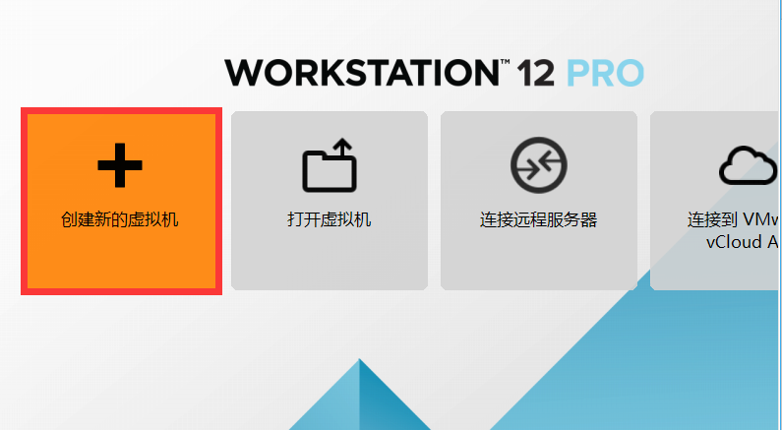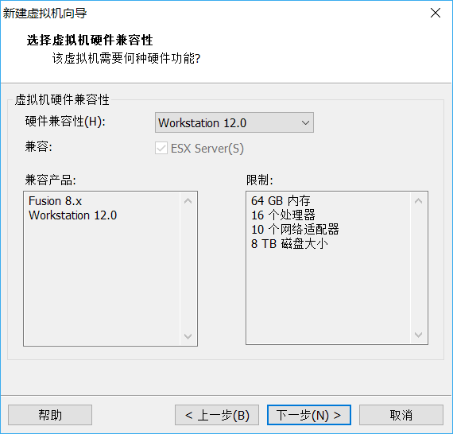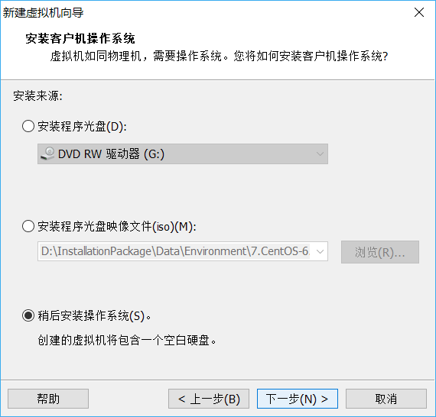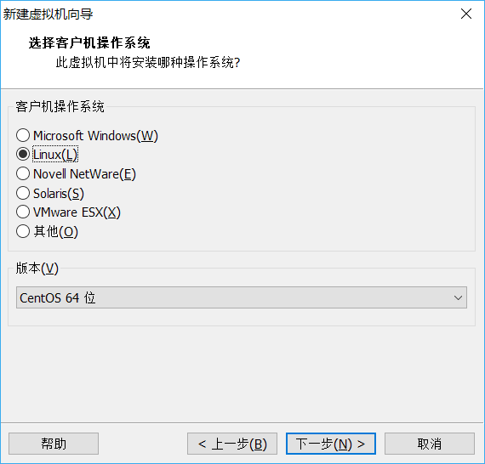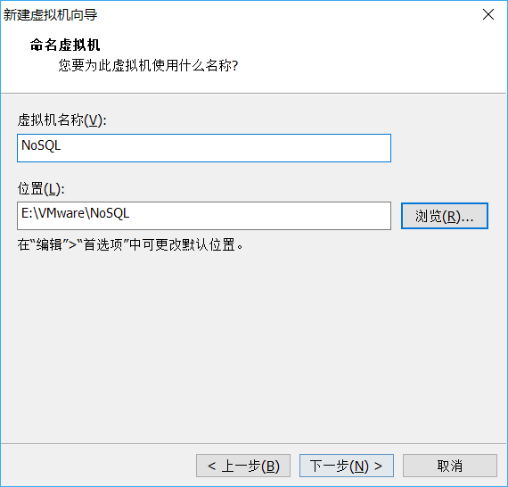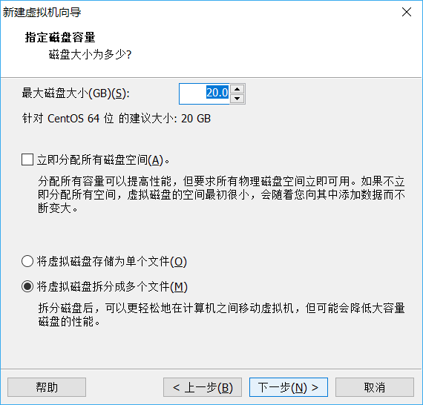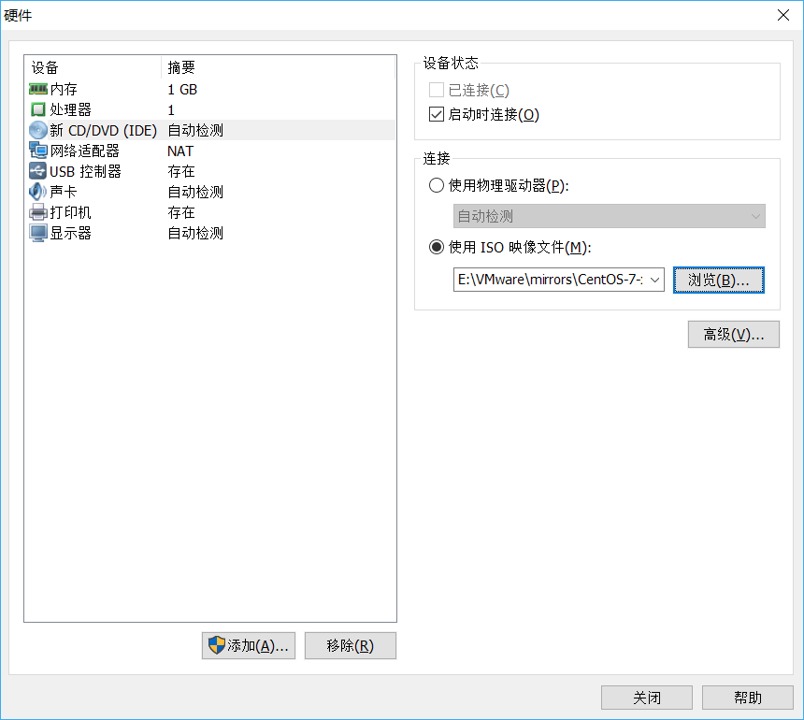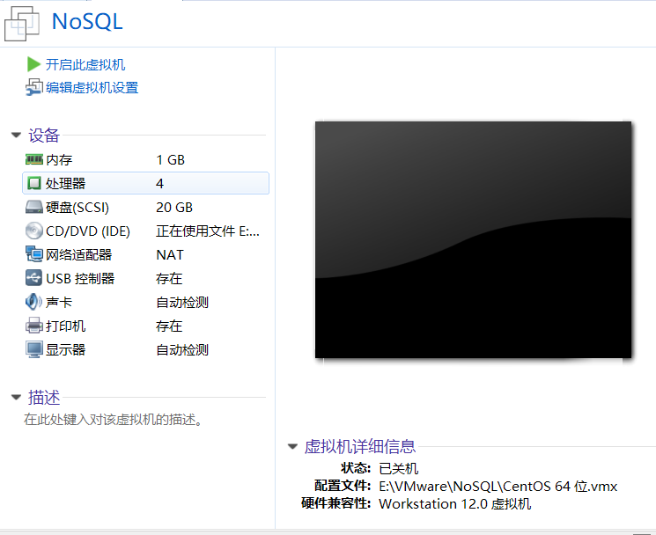



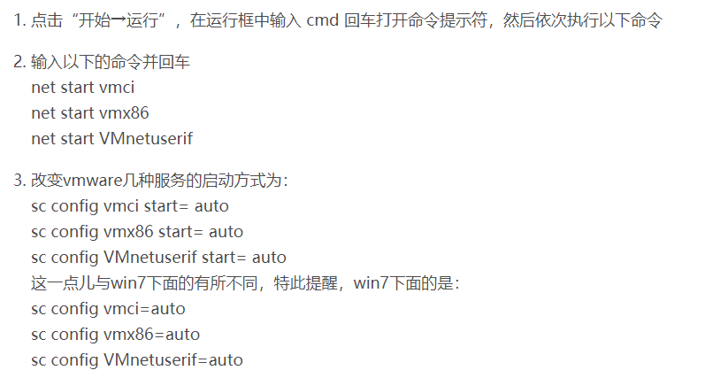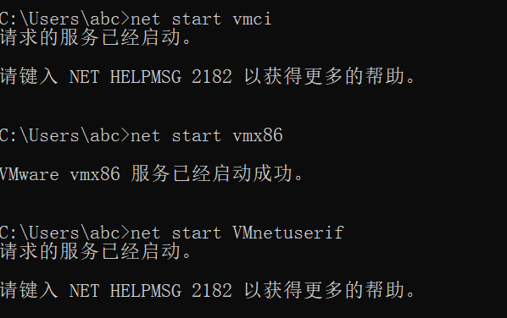

# 远程连接虚拟机

ifconfig

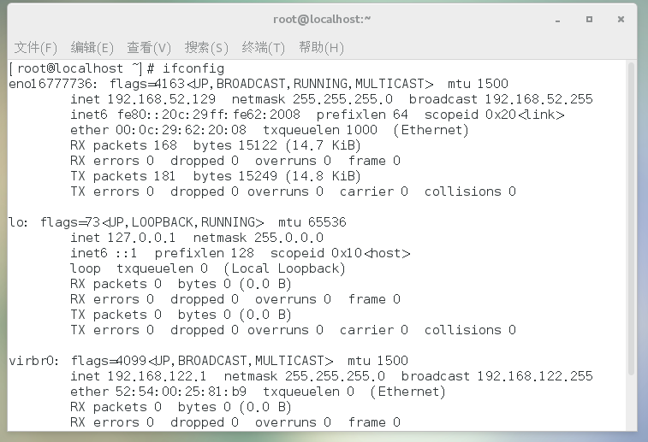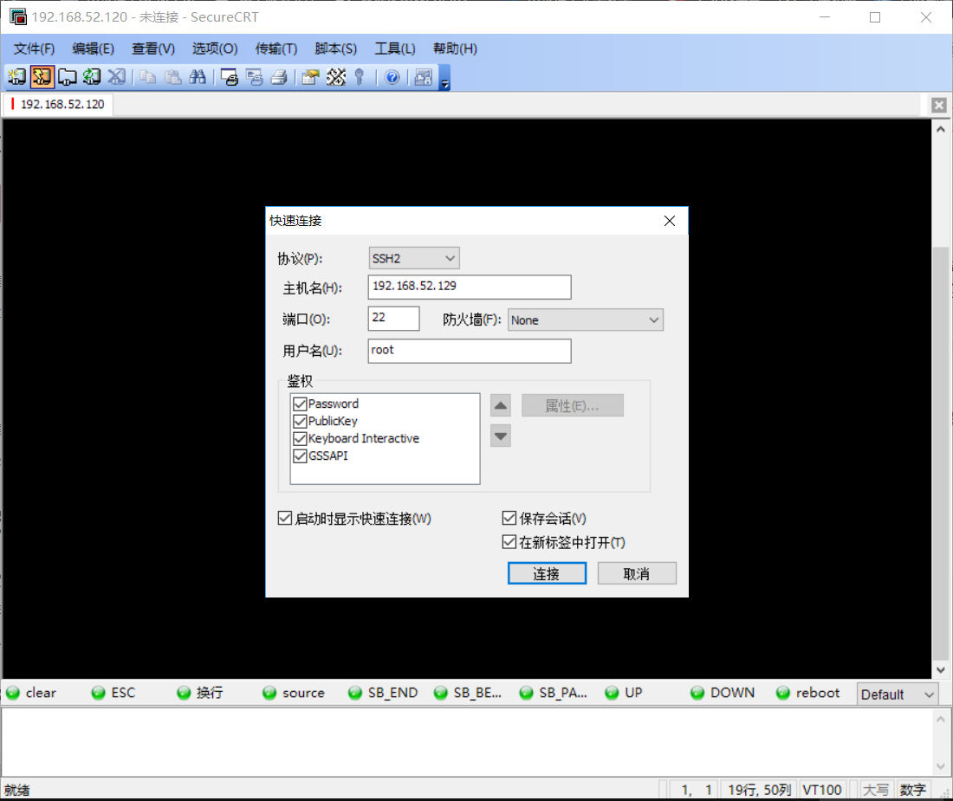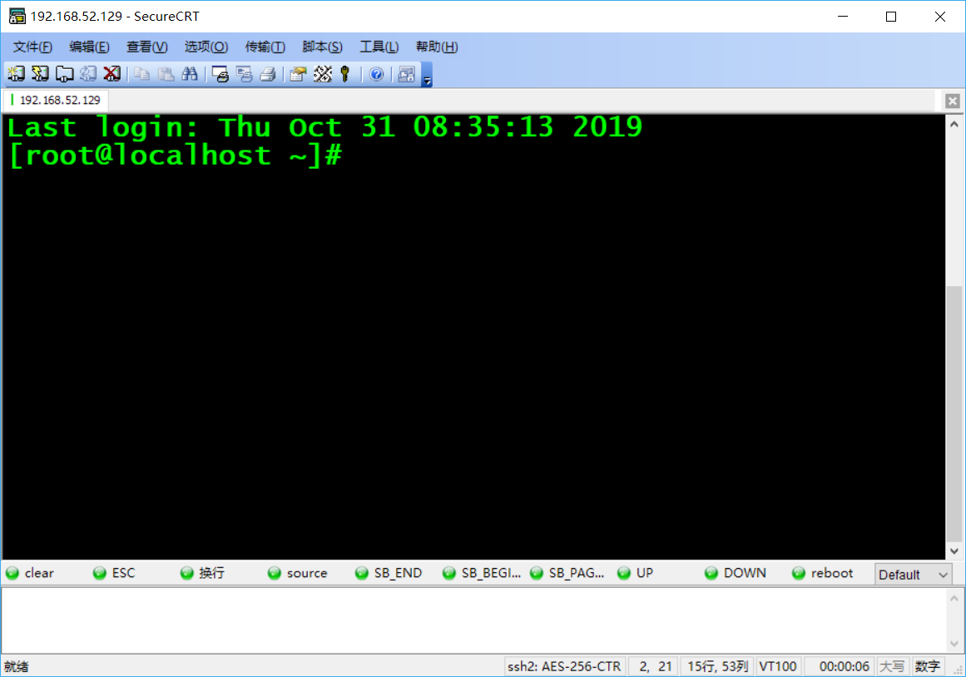

# HDFS伪分布式搭建

## 查看自带的openjdk

rpm -qa | grep java

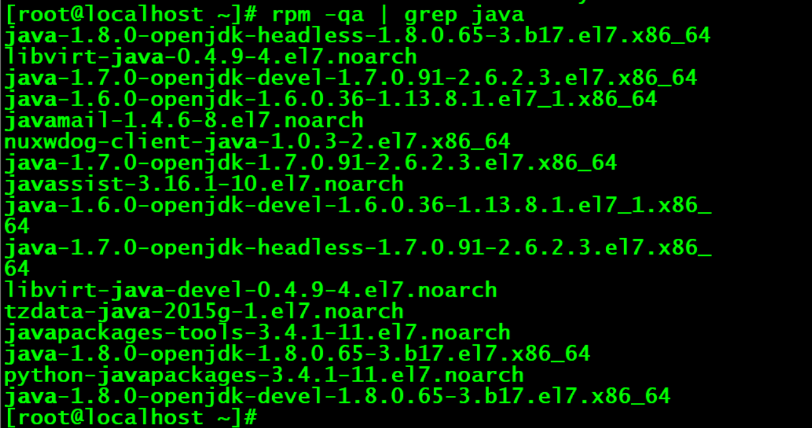

## 卸载系统自带的openjdk

rpm -e java-1.8.0-openjdk-headless-1.8.0.65-3.b17.el7.x86_64 libvirt-java-0.4.9-4.el7.noarch java-1.7.0-openjdk-devel-1.7.0.91-2.6.2.3.el7.x86_64 java-1.6.0-openjdk-1.6.0.36-1.13.8.1.el7_1.x86_64 javamail-1.4.6-8.el7.noarch nuxwdog-client-java-1.0.3-2.el7.x86_64 java-1.7.0-openjdk-1.7.0.91-2.6.2.3.el7.x86_64 javassist-3.16.1-10.el7.noarch java-1.6.0-openjdk-devel-1.6.0.36-1.13.8.1.el7_1.x86_64 java-1.7.0-openjdk-headless-1.7.0.91-2.6.2.3.el7.x86_64 libvirt-java-devel-0.4.9-4.el7.noarch tzdata-java-2015g-1.el7.noarch javapackages-tools-3.4.1-11.el7.noarch java-1.8.0-openjdk-1.8.0.65-3.b17.el7.x86_64 python-javapackages-3.4.1-11.el7.noarch java-1.8.0-openjdk-devel-1.8.0.65-3.b17.el7.x86_64 --nodeps

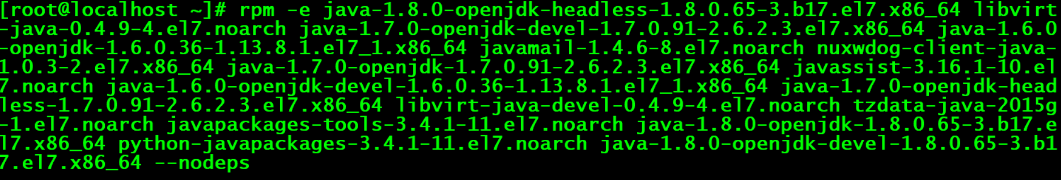

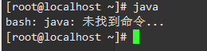

## 各台虚拟机关闭防火墙

各台机器执行以下命令（root用户来执行）

service iptables stop

chkconfig iptables off

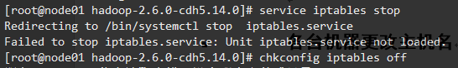

1:查看防火状态

systemctl status firewalld

service iptables status

2:暂时关闭防火墙

systemctl stop firewalld

service iptables stop

3:永久关闭防火墙

systemctl disable firewalld

chkconfig iptables off

4:重启防火墙

systemctl enable firewalld

service iptables restart

5:永久关闭后重启

chkconfig iptables on

## 各台机器关闭selinux（linux里面的安全策略，类似防火墙）

vim /etc/selinux/config

## 各台机器更改主机名

vim /etc/sysconfig/network



NETWORKING=yes

HOSTNAME=node01.hadoop.com



## 各台机器做主机名与IP地址的映射

vim /etc/hosts

192.168.52.129 node01.hadoop.com node01

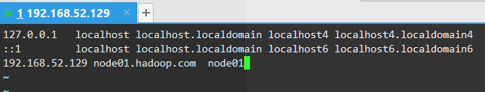

## 各台机器重启

reboot -h now

## 创建文件夹

mkdir -p /export/servers

mkdir -p /export/softwares



yum install lrzsz

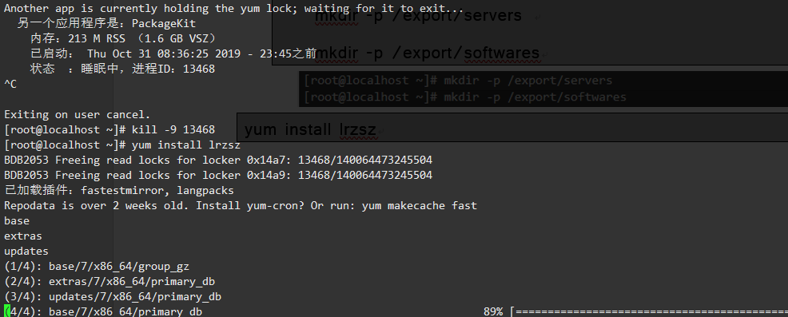

cd /export/softwares

rz

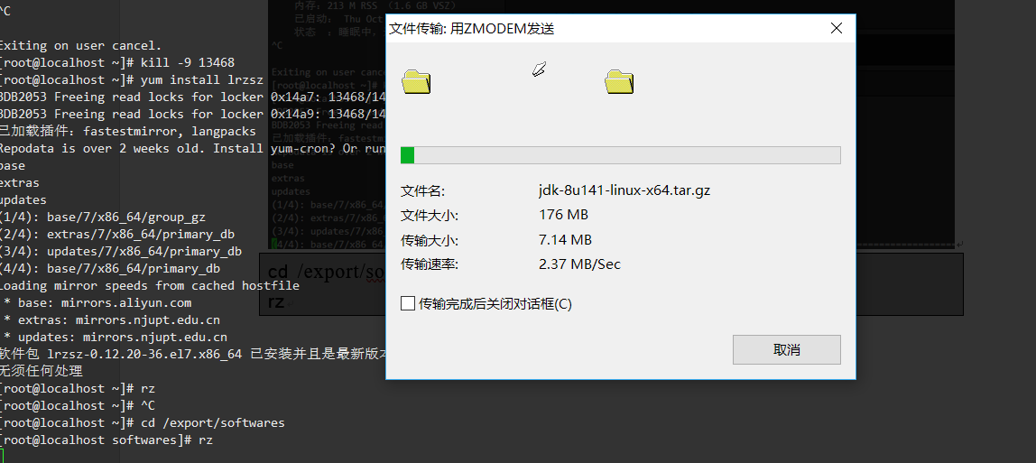

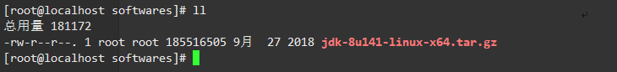

tar -zxvf jdk-8u141-linux-x64.tar.gz -C ../servers/

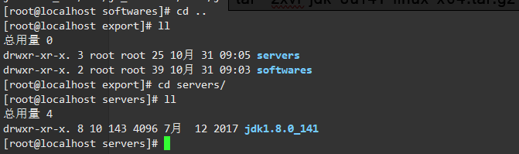

## 配置环境变量

vim /etc/profile

export JAVA_HOME=/export/servers/jdk1.8.0_141

export PATH=:$JAVA_HOME/bin:$PATH

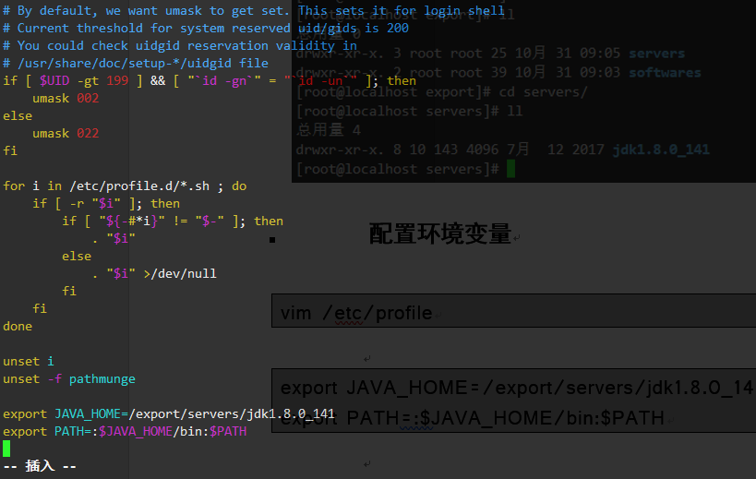

source /etc/profile



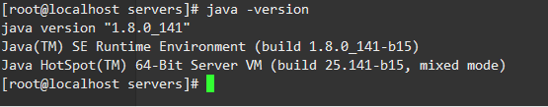

## 安装ssh

sudo yum install ssh

ssh-keygen -t rsa

cp ~/.ssh/id_rsa.pub ~/.ssh/authorized_keys

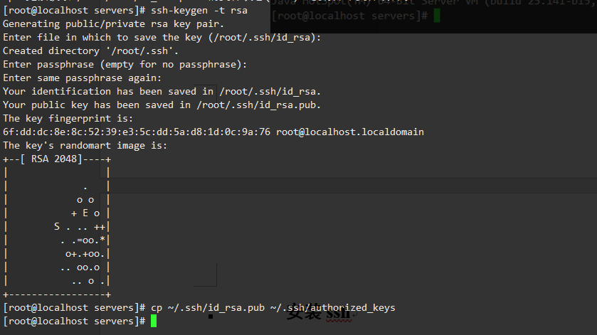

cd /export/softwares/  
rz

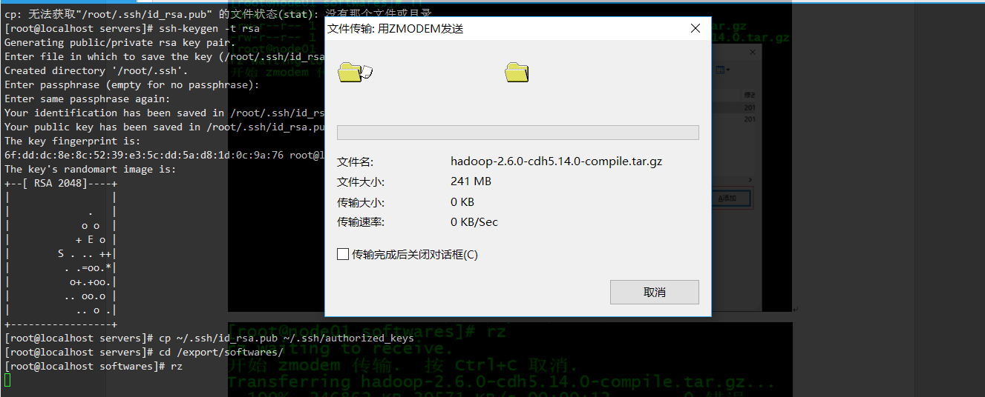

mv hadoop-2.6.0-cdh5.14.0-compile.tar.gz hadoop-2.6.0-cdh5.14.0.tar.gz

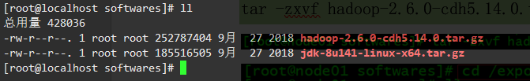

tar -zxvf hadoop-2.6.0-cdh5.14.0.tar.gz -C ../servers/

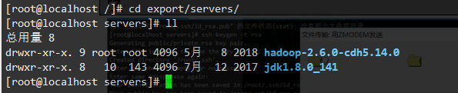

cd /export/servers/hadoop-2.6.0-cdh5.14.0

bin/hadoop checknative

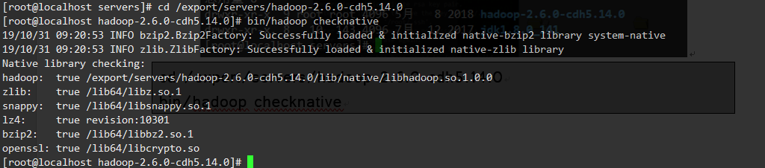

## 修改core-site.xml

cd /export/servers/hadoop-2.6.0-cdh5.14.0/etc/hadoop

vim core-site.xml

<configuration>

<property>

<name>fs.defaultFS</name>

<value>hdfs://node01:8020</value>

</property>

<property>

<name>hadoop.tmp.dir</name>

<value>/export/servers/hadoop-2.6.0-cdh5.14.0/hadoopDatas/tempDatas</value>

</property>

<property>

<name>io.file.buffer.size</name>

<value>4096</value>

</property>

<property>

<name>fs.trash.interval</name>

<value>10080</value>

</property>

</configuration>

## 修改hdfs-site.xml

cd /export/servers/hadoop-2.6.0-cdh5.14.0/etc/hadoop

vim hdfs-site.xml

<configuration>

<property>

<name>dfs.namenode.secondary.http-address</name>

<value>node01:50090</value>

</property>

<property>

<name>dfs.namenode.http-address</name>

<value>node01:50070</value>

</property>

<property>

<name>dfs.namenode.name.dir</name>

<value>file:///export/servers/hadoop-2.6.0-cdh5.14.0/hadoopDatas/namenodeDatas</value>

</property>

<property>

<name>dfs.datanode.data.dir</name>

<value>file:///export/servers/hadoop-2.6.0-cdh5.14.0/hadoopDatas/datanodeDatas</value>

</property>

<property>

<name>dfs.namenode.edits.dir</name>

<value>file:///export/servers/hadoop-2.6.0-cdh5.14.0/hadoopDatas/dfs/nn/edits</value>

</property>

<property>

<name>dfs.namenode.checkpoint.dir</name>

<value>file:///export/servers/hadoop-2.6.0-cdh5.14.0/hadoopDatas/dfs/snn/name</value>

</property>

<property>

<name>dfs.namenode.checkpoint.edits.dir</name>

<value>file:///export/servers/hadoop-2.6.0-cdh5.14.0/hadoopDatas/dfs/nn/snn/edits</value>

</property>

<property>

<name>dfs.replication</name>

<value>1</value>

</property>

<property>

<name>dfs.permissions</name>

<value>false</value>

</property>

<property>

<name>dfs.blocksize</name>

<value>134217728</value>

</property>

</configuration>

## 修改hadoop-env.sh

cd /export/servers/hadoop-2.6.0-cdh5.14.0/etc/hadoop

vim hadoop-env.sh

export JAVA_HOME=/export/servers/jdk1.8.0_141

## 修改mapred-site.xml

cd /export/servers/hadoop-2.6.0-cdh5.14.0/etc/hadoop

vim mapred-site.xml

<configuration>

<property>

<name>mapreduce.framework.name</name>

<value>yarn</value>

</property>

<property>

<name>mapreduce.job.ubertask.enable</name>

<value>true</value>

</property>

<property>

<name>mapreduce.jobhistory.address</name>

<value>node01:10020</value>

</property>

<property>

<name>mapreduce.jobhistory.webapp.address</name>

<value>node01:19888</value>

</property>

</configuration>

## 修改yarn-site.xml

cd /export/servers/hadoop-2.6.0-cdh5.14.0/etc/hadoop

vim yarn-site.xml

<configuration>

<property>

<name>yarn.resourcemanager.hostname</name>

<value>node01</value>

</property>

<property>

<name>yarn.nodemanager.aux-services</name>

<value>mapreduce_shuffle</value>

</property>

<property>

<name>yarn.log-aggregation-enable</name>

<value>true</value>

</property>

<property>

<name>yarn.log-aggregation.retain-seconds</name>

<value>604800</value>

</property>

</configuration>

## 修改slaves文件

cd /export/servers/hadoop-2.6.0-cdh5.14.0/etc/hadoop

vim slaves

## 创建文件存放目录

mkdir -p /export/servers/hadoop-2.6.0-cdh5.14.0/hadoopDatas/tempDatas

mkdir -p /export/servers/hadoop-2.6.0-cdh5.14.0/hadoopDatas/namenodeDatas

mkdir -p /export/servers/hadoop-2.6.0-cdh5.14.0/hadoopDatas/datanodeDatas

mkdir -p /export/servers/hadoop-2.6.0-cdh5.14.0/hadoopDatas/dfs/nn/edits

mkdir -p /export/servers/hadoop-2.6.0-cdh5.14.0/hadoopDatas/dfs/snn/name

mkdir -p /export/servers/hadoop-2.6.0-cdh5.14.0/hadoopDatas/dfs/nn/snn/edits

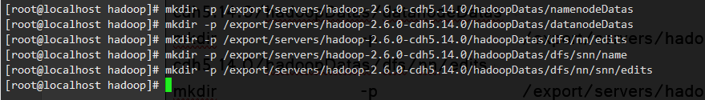

## 配置hadoop的环境变量

vim /etc/profile

export HADOOP_HOME=/export/servers/hadoop-2.6.0-cdh5.14.0

export PATH=:$HADOOP_HOME/bin:$HADOOP_HOME/sbin:$PATH

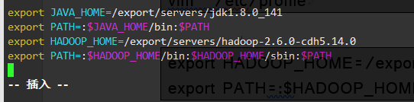

source /etc/profile

## 集群启动

要启动 Hadoop 集群，需要启动 HDFS 和 YARN 两个集群。

注意：首次启动HDFS时，必须对其进行格式化操作。本质上是一些清理和准备工作，因为此时的 HDFS 在物理上还是不存在的。

cd /export/servers/hadoop-2.6.0-cdh5.14.0/

bin/hdfs namenode -format

## 脚本一键启动

cd /export/servers/hadoop-2.6.0-cdh5.14.0/

sbin/start-dfs.sh

sbin/start-yarn.sh

sbin/mr-jobhistory-daemon.sh start historyserver

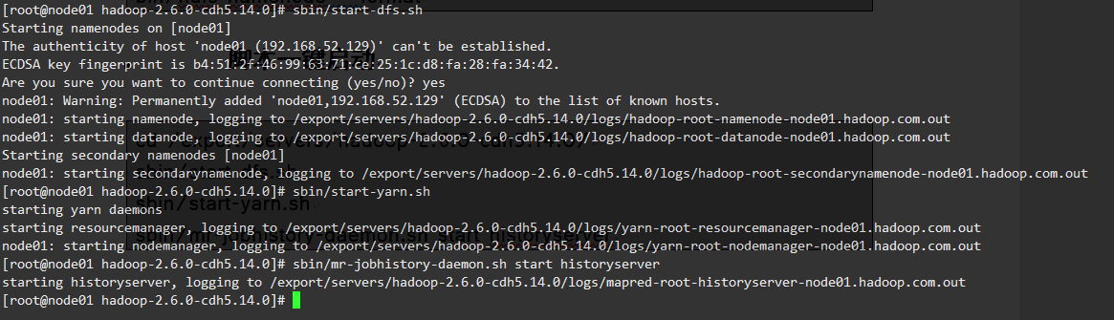

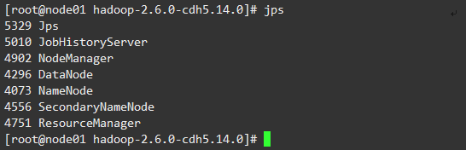

## 停止集群

sbin/stop-dfs.sh

sbin/stop-yarn.sh

sbin/mr-jobhistory-daemon.sh stop historyserver

## 浏览器查看启动页面

### hdfs集群访问地址

<http://192.168.52.129:50070/dfshealth.html#tab-overview>

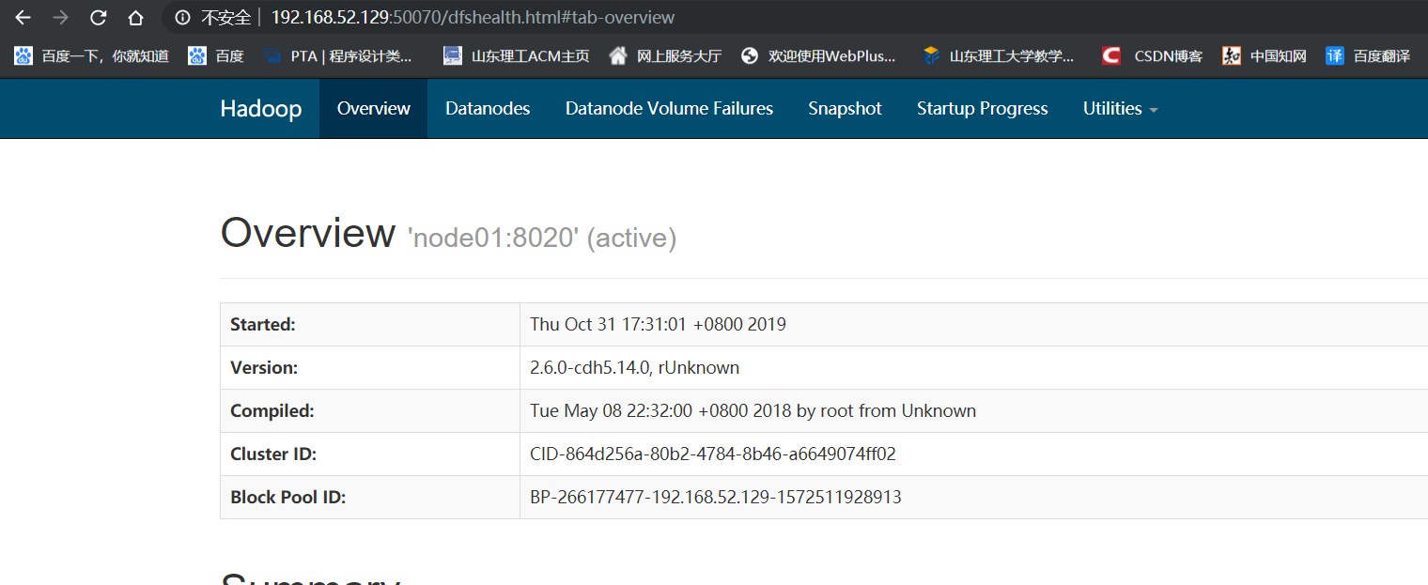

### yarn集群访问地址

<http://192.168.52.129:8088/cluster>

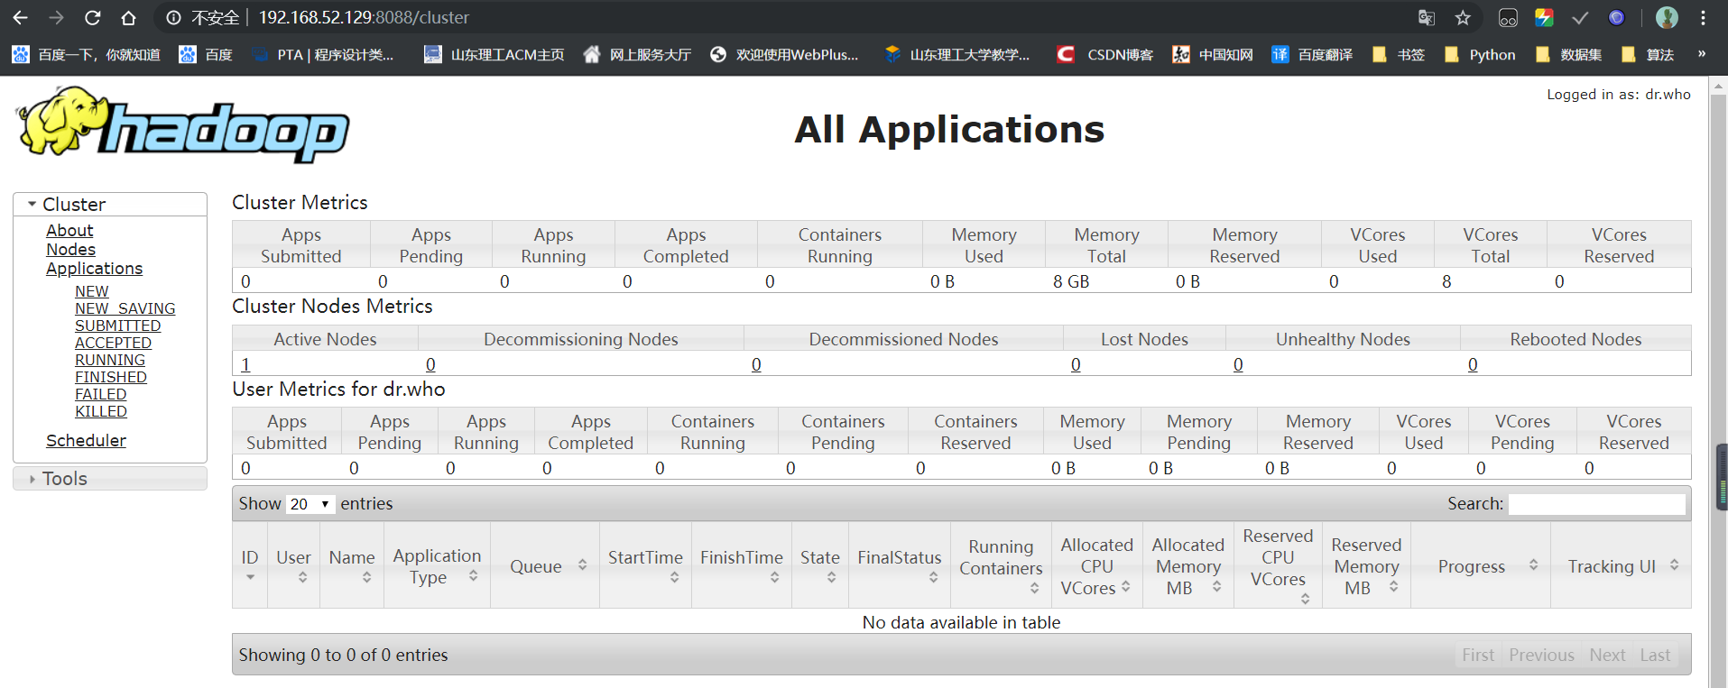

### jobhistory访问地址

<http://192.168.52.129:19888/jobhistory>

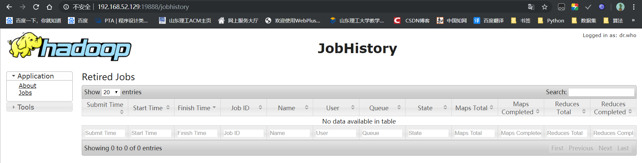

# Hbase安装

## 使用wget下载Hbase

wget http://archive.apache.org/dist/hbase/1.4.8/hbase-1.4.8-bin.tar.gz

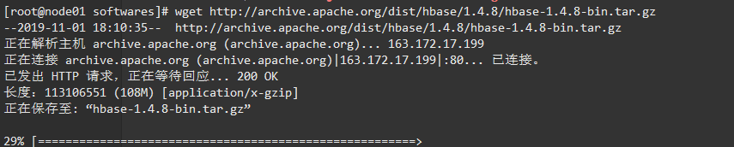

## 解压目录

tar -zxvf hbase-1.4.8-bin.tar.gz -C ../servers/

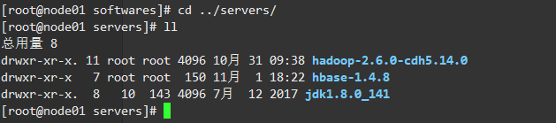

mkdir /export/servers/hbase-1.4.8/zk_data

## 设置hbase环境变量

vi /etc/profile

export HBASE_HOME=/export/servers/hbase-1.4.8

export PATH=:$HBASE_HOME/bin:$PATH

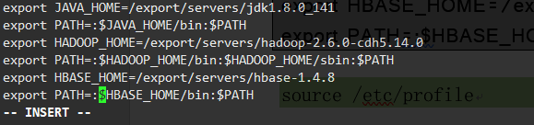

source /etc/profile

## 配置 hbase-env.sh文件

vi /export/servers/hbase-1.4.8/conf/hbase-env.sh

export JAVA_HOME=/export/servers/jdk1.8.0_141/

export HBASE_MANAGES_ZK=true #此配置信息，设置由hbase自己管理zookeeper，不需要单独的zookeeper

export HBASE_PID_DIR=/export/servers/hbase-1.4.8/pids

## 配置 hbase-site.xml

vi /export/servers/hbase-1.4.8/conf/hbase-site.xml



<configuration>

<property>

<name>hbase.rootdir</name>

<value>hdfs://node01:8020/hbase</value>

</property>

<property>

<name>hbase.cluster.distributed</name>

<value>true</value>

</property>

<property>

<name>hbase.zookeeper.quorum</name>

<value>node01</value>

</property>

<property>

<name>hbase.zookeeper.property.dataDir</name>

<value>/export/servers/hbase-1.4.8/zk_data</value>

</property>

</configuration>

## 启动hbase

start-hbase.sh

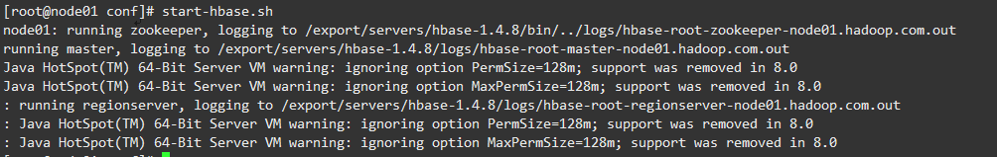

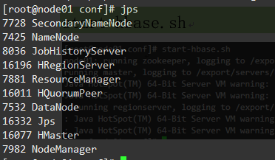

## 进入hbase shell

hbase shell

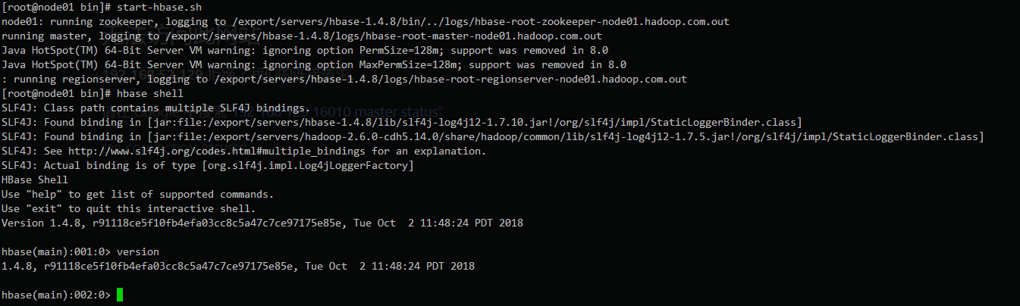

## 进入hbase的web页面

<http://192.168.52.129:16010/>

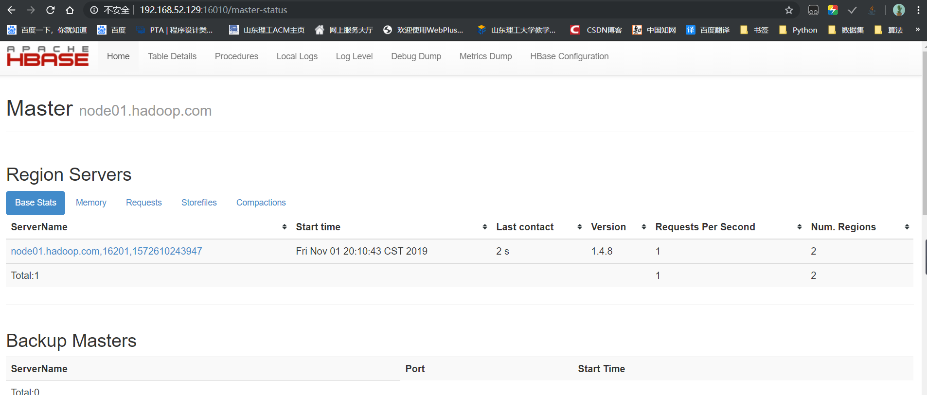

# HBase shell

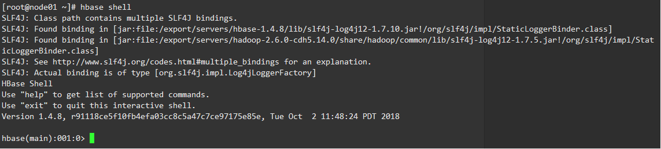

version：显示当前HBase版本号



status：显示各个主节点状态



whoami：显示当前用户名

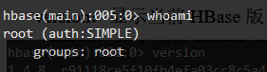

# 表和列族操作

## 创建表

create 'player','basic'

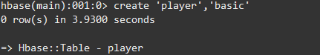

大小写参数敏感

create 'PLAYER','basic'

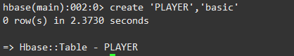

建表时指定列族的参数

create 'PLAYER1',{NAME=>'basic',VERSIONS=>5,BLOCKCACHE=>true}

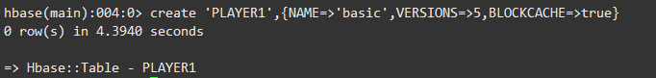

## 查看表名列表

list

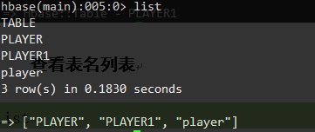

exists 'player'

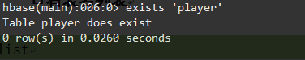

## 描述表结构

describe 'player'

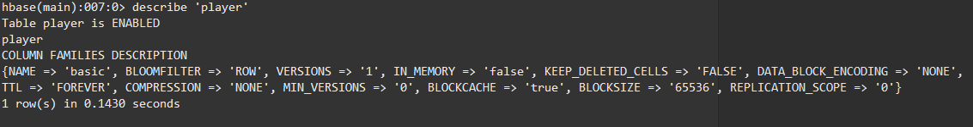

Hbase Web界面

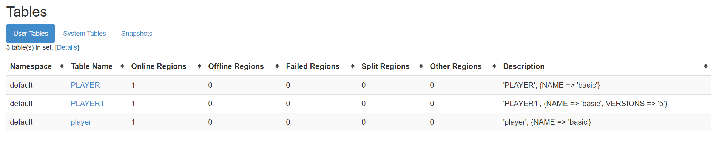

## 修改表结构

增加列族

alter 'player','advanced'

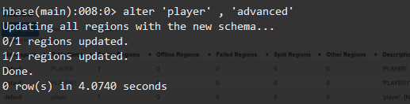

alter 'player','basic',{NAME=>'advanced',IN_MEMORY=>true}

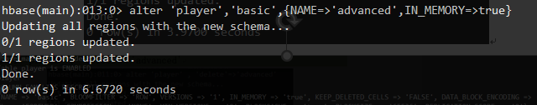

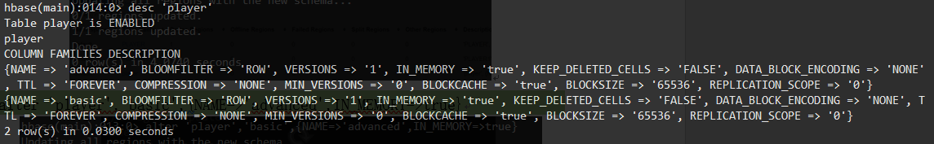

修改列族属性

alter 'player',{NAME=>'basic',IN_MEMORY=>true}

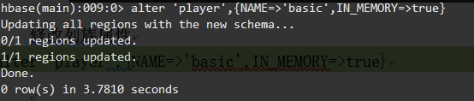

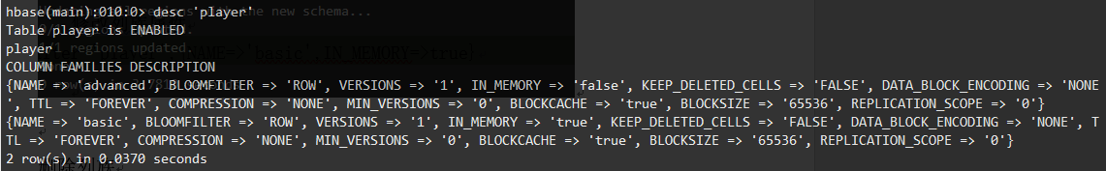

删除列族

alter 'player' , 'delete'=>'advanced'

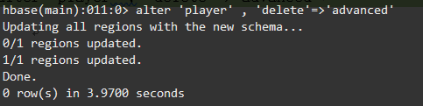

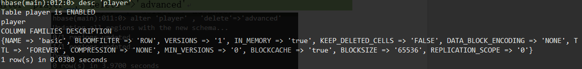

alter 'player','basic',{NAME=>'advanced',METHOD=>'delete'}

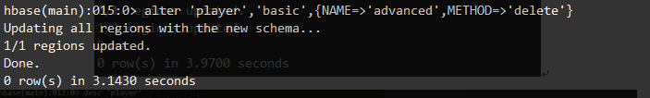

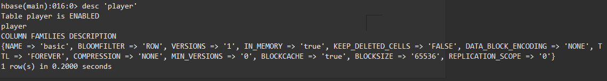

## 删除表

disable 'player'



is_disabled 'player'

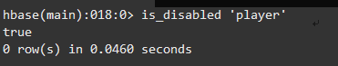

drop 'player'



数据清空

truncate 'player'

## 数据更新

数据插入

put 'player' ,'001','basic:pl','MJ'



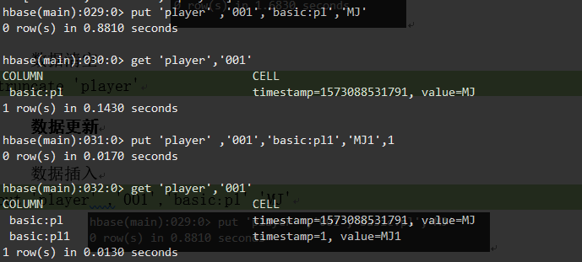

数据更新

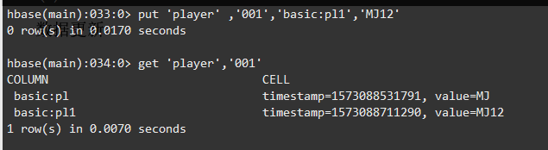

数据删除

delete 'player','001','basic:lastname'

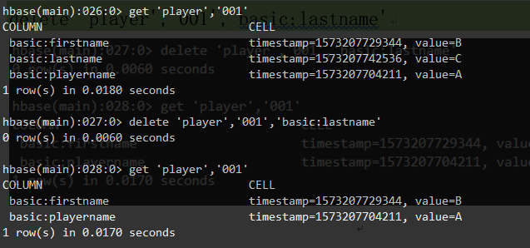

delete 'player','001','basic:lastname1',2

所有时间戳小于等于2的数据都会删掉

deleteall 'player','001'

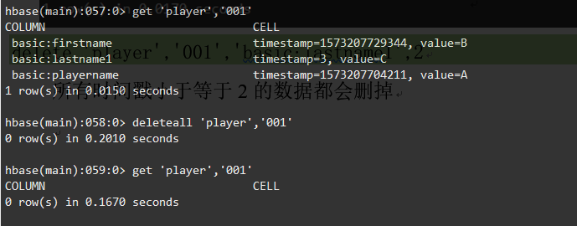

## 计数器

incr 'player','002','basic:scores',10

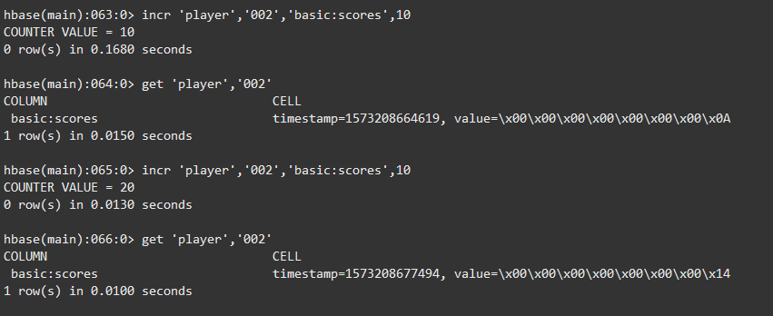

get_counter 'player' ,'002','basic:scores'



## 数据查询

get 'player','002'



数据扫描

scan 'player'

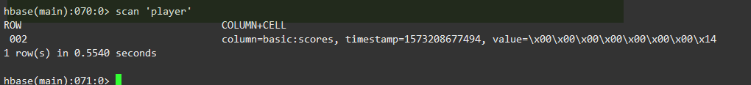

## 过滤查询

show_filters

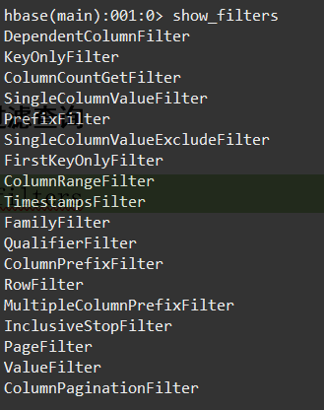

### 行键过滤器

scan 'player' ,FILTER=>"RowFilter(=,'substring:01')"

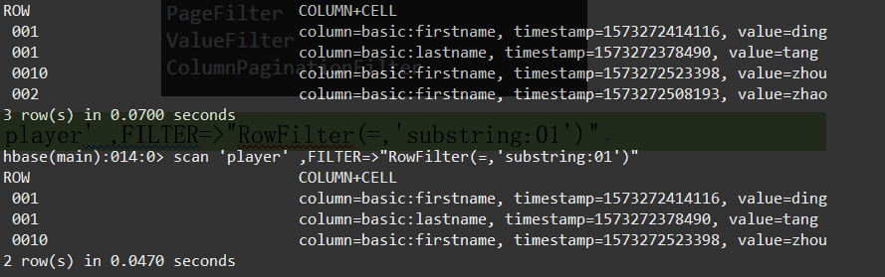

scan 'player' ,FILTER=>"RowFilter(<,'binary:002')"

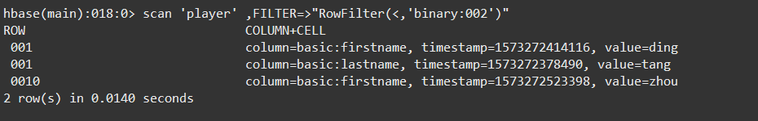

scan 'player' ,FILTER=>"PrefixFilter('001')"

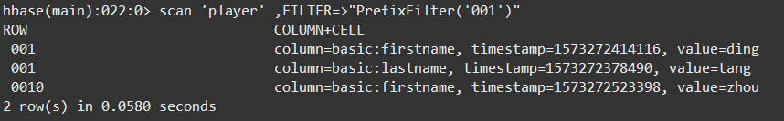

scan 'player' ,{STARTROW=>'001',ENDROW=>'002'}

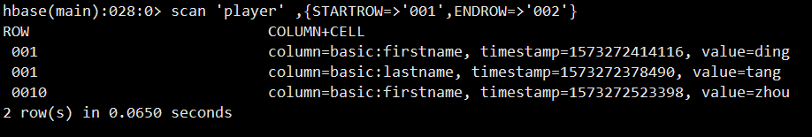

scan 'player' ,{STARTROW=>'001',FILTER=>"InclusiveStopFilter('binary:001')"}

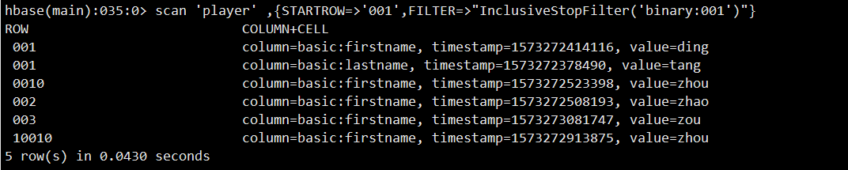

### 列族和列过滤器

scan 'player' ,FILTER=>"FamilyFilter(=,'substring:basic')"

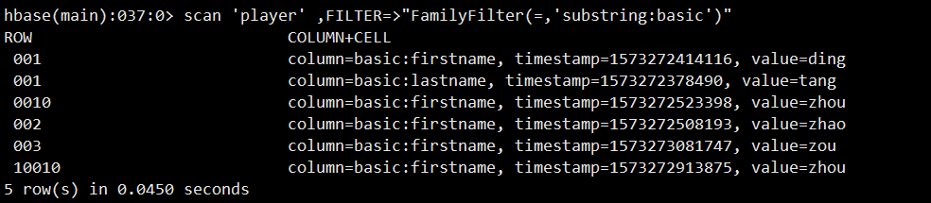

scan 'player' ,FILTER=>"QualifierFilter(=,'substring:name')"

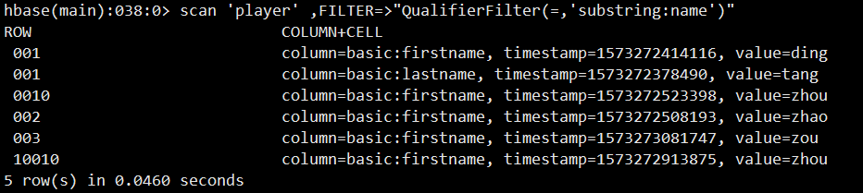

scan 'player' ,FILTER=>"ColumnPrefixFilter('f')"

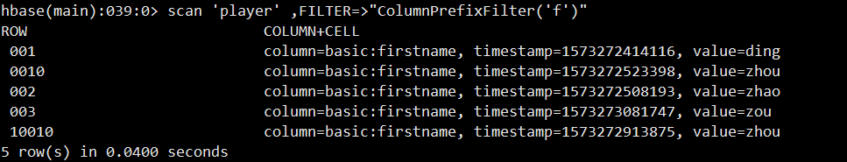

scan 'player' ,FILTER=>"MultipleColumnPrefixFilter('f','l')"

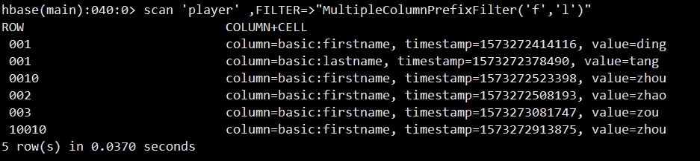

scan 'player',{FILTER=>"TimestampsFilter(1573272378490,1573273081747)"}

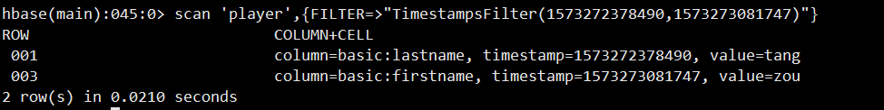

scan 'player',{FILTER=>"ColumnRangeFilter('f',false,'lastname',true)"}

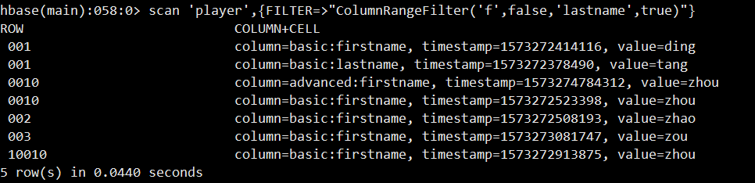

scan 'player',{FILTER=>"DependentColumnFilter('basic','firstname',false)"}

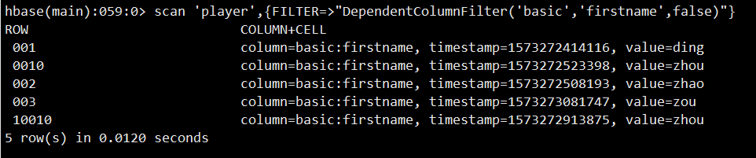

### 值过滤器

scan 'player',{FILTER=>"ValueFilter(=,'binary:zhou')"}

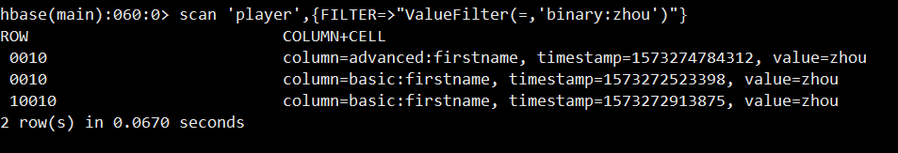

scan 'player',{COLUMN=>'basic:firstname',FILTER=>"SingleColumnValueFilter('basic','firstname',=,'binary:ding')"}

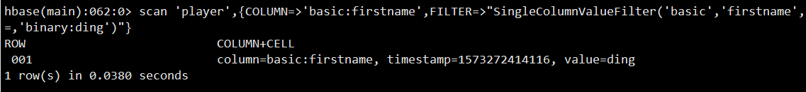

## 其他过滤器

scan 'player',FILTER=>"ColumnPrefixFilter('first') AND ValueFilter(=,'substring:zh')"

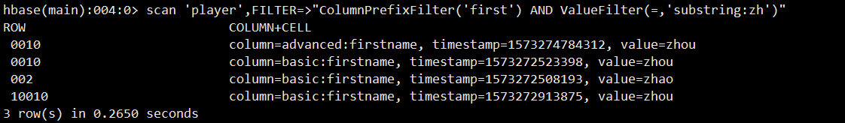

## 快照操作

建立快照

snapshot 'player' ,'pl'



显示快照列表

list_snapshots

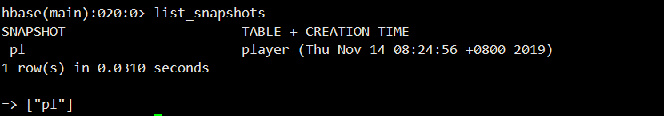

删除快照

delete_snapshot 'pl'



通过快照生成新表

clone_snapshot 'pl','play_1'

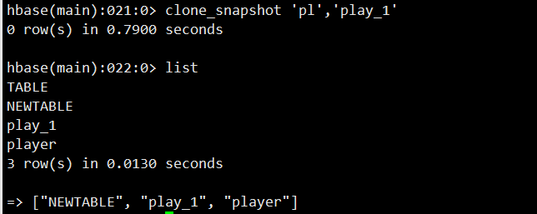

# Java访问Hbase

pom.xml

<dependency>

<groupId>org.apache.hbase</groupId>

<artifactId>hbase-client</artifactId>

<version>1.4.8</version>

</dependency>

## 建立连接

public static Configuration conf;

public static Connection connection;

public void getconncet(){

conf= HBaseConfiguration.create();

conf.set("hbase.zookeeper.quorum","node");

conf.set("hbase.zookeeper.property.clientPort","2181");

conf.set("zookeeper.znode.parent","/hbase");

conf.set("hbase.master", "node:16000");

try{

connection=ConnectionFactory.createConnection(conf);

} catch (IOException e) {

e.printStackTrace();

}

}

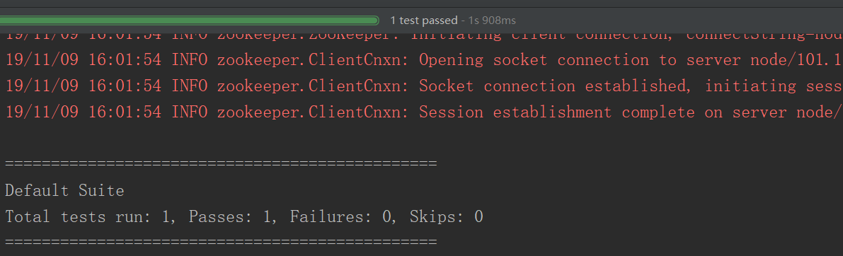

## 建立和删除表

public void createtable() throws IOException {

getconncet();

TableName tableName =TableName.valueOf("NEWTABLE");

Admin admin = connection.getAdmin();

if (admin.tableExists(tableName)){

admin.disableTable(tableName);

admin.deleteTable(tableName);

System.out.println(tableName.toString()+"is exists, delete it..............");

}

HTableDescriptor descriptor = new HTableDescriptor(tableName);

HColumnDescriptor columnDescriptor = new HColumnDescriptor("cf1");

columnDescriptor.setBloomFilterType(BloomType.ROWCOL);

descriptor.addFamily(columnDescriptor);

descriptor.addFamily(new HColumnDescriptor("cf2"));

admin.createTable(descriptor);

admin.close();

}

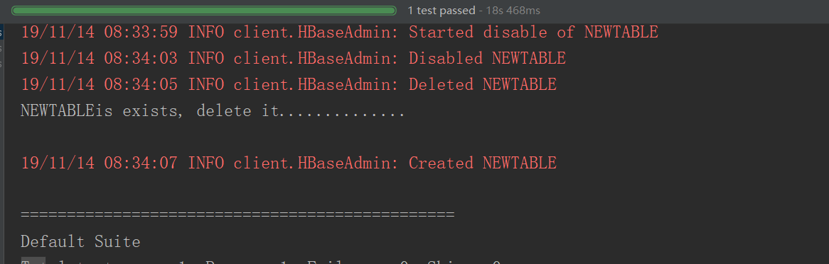

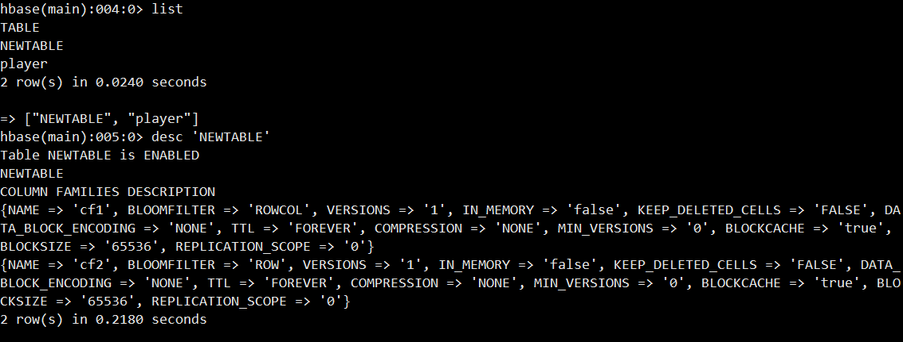

## 描述表结构

public void desctable() throws IOException {

getconncet();

TableName tableName =TableName.valueOf("player");

Admin admin = connection.getAdmin();

HTableDescriptor descriptor=admin.getTableDescriptor(tableName);

System.out.println(descriptor.toString());

}

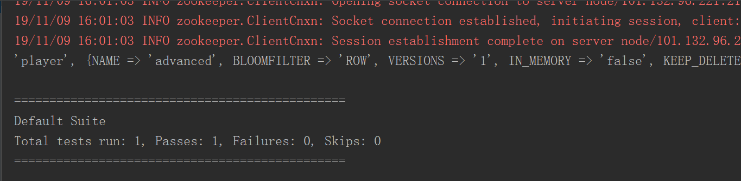

public void desctable() throws IOException {

getconncet();

TableName tableName =TableName.valueOf("NEWTABLE");

Admin admin = connection.getAdmin();

HTableDescriptor descriptor=admin.getTableDescriptor(tableName);

System.out.println(descriptor.toString());

System.out.println("table information:......................");

System.out.println("getNameAsString:"+descriptor.getNameAsString());

System.out.println("getMaxFileSize:"+descriptor.getMaxFileSize());

System.out.println("getMemStoreFlushSize:"+descriptor.getMemStoreFlushSize());

System.out.println("getRegionSplitPolicyClassName:"+descriptor.getRegionSplitPolicyClassName());

System.out.println("getRegionSplitPolicyClassName:"+descriptor.getRegionSplitPolicyClassName());

Collection<HColumnDescriptor>families=descriptor.getFamilies();

System.out.println("Column family infomation...................");

for (HColumnDescriptor result:families){

System.out.println("getNameAsString:"+result.getNameAsString());

System.out.println("getBloomFilterType:"+result.getBloomFilterType());

System.out.println("getBlocksize:"+result.getBlocksize());

System.out.println("getMaxVersions:"+result.getMaxVersions());

System.out.println("getMinVersions:"+result.getMinVersions());

}

admin.close();

}

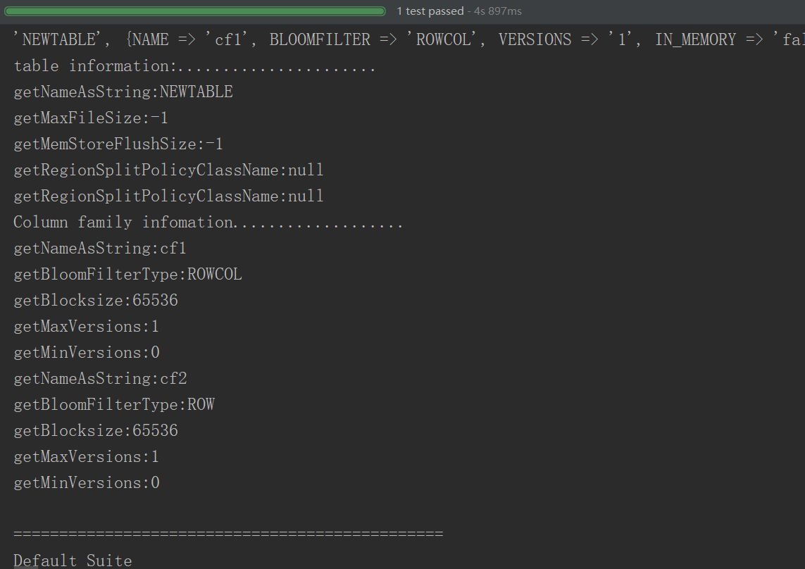

## 数据更新

public void addData() throws IOException{

getconncet();

HTable table=(HTable)connection.getTable(TableName.valueOf("NEWTABLE"));

table.setWriteBufferSize(6*1024*1024);

table.setAutoFlushTo(false);

Put put=new Put(Bytes.toBytes("row1"));

put.setDurability(Durability.SKIP_WAL);

put.addColumn(Bytes.toBytes("cf1"),Bytes.toBytes("col0"),Bytes.toBytes("value0"));

put.addColumn(Bytes.toBytes("cf1"),Bytes.toBytes("col1"),Bytes.toBytes("value1"));

put.addColumn(Bytes.toBytes("cf2"),Bytes.toBytes("col2"),Bytes.toBytes("value2"));

put.addColumn(Bytes.toBytes("cf2"),Bytes.toBytes("col3"),Bytes.toBytes("value3"));

table.put(put);

table.flushCommits();

Put put2=new Put("row2".getBytes());

put2.setDurability(Durability.SKIP_WAL);

put2.addColumn(Bytes.toBytes("cf1"),Bytes.toBytes("col0"),Bytes.toBytes("value4"));

put2.addColumn(Bytes.toBytes("cf1"),Bytes.toBytes("col4"),Bytes.toBytes("value5"));

put2.addColumn(Bytes.toBytes("cf2"),Bytes.toBytes("col3"),Bytes.toBytes("value6"));

put2.addColumn(Bytes.toBytes("cf2"),Bytes.toBytes("col5"),Bytes.toBytes("value7"));

table.put(put2);

table.flushCommits();

Put put3=new Put("row3".getBytes());

put3.setDurability(Durability.SKIP_WAL);

put3.addColumn(Bytes.toBytes("cf1"),Bytes.toBytes("col0"),Bytes.toBytes("value4"));

put3.addColumn(Bytes.toBytes("cf1"),Bytes.toBytes("col6"),Bytes.toBytes("value8"));

put3.addColumn(Bytes.toBytes("cf2"),Bytes.toBytes("col3"),Bytes.toBytes("value9"));

put3.addColumn(Bytes.toBytes("cf2"),Bytes.toBytes("col7"),Bytes.toBytes("value10"));

Put put4=new Put("row4".getBytes());

put4.setDurability(Durability.SKIP_WAL);

put4.addColumn(Bytes.toBytes("cf1"),Bytes.toBytes("col0"),Bytes.toBytes("value11"));

put4.addColumn(Bytes.toBytes("cf1"),Bytes.toBytes("col8"),Bytes.toBytes("value8"));

put4.addColumn(Bytes.toBytes("cf2"),Bytes.toBytes("col3"),Bytes.toBytes("value9"));

put4.addColumn(Bytes.toBytes("cf2"),Bytes.toBytes("col9"),Bytes.toBytes("value12"));

List<Put>putList=new ArrayList<Put>();

putList.add(put3);

putList.add(put4);

table.put(putList);

table.flushCommits();

table.close();

}

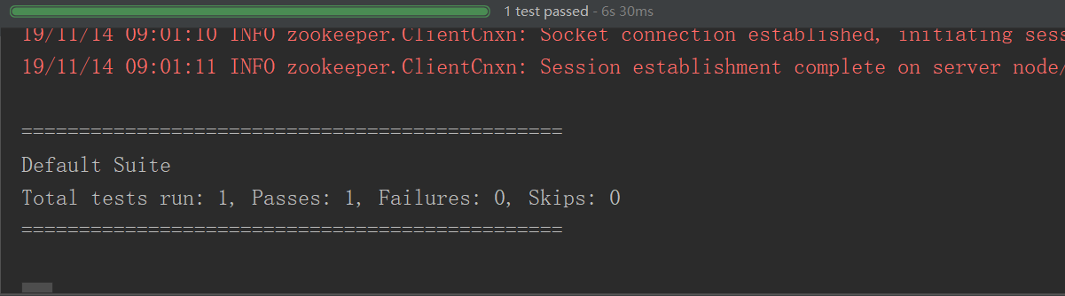

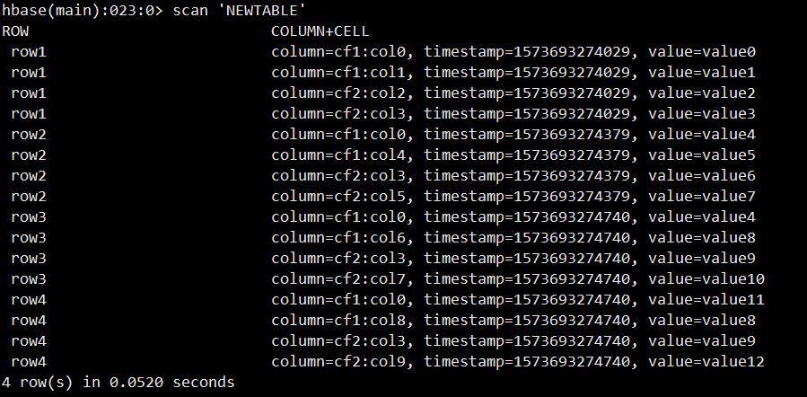

## 数据查询

get方法

private void getData() throws IOException{

getconncet();

Table table =connection.getTable(TableName.valueOf("NEWTABLE"));

Get get=new Get(Bytes.toBytes("row1"));

Result result=table.get(get);

for (Cell cell:result.rawCells()){

System.out.println(new String(CellUtil.getCellKeyAsString(cell))+":"+new String(CellUtil.cloneFamily(cell))+":"+new String(CellUtil.cloneValue(cell))+":"+cell.getTimestamp());

}

table.close();

}

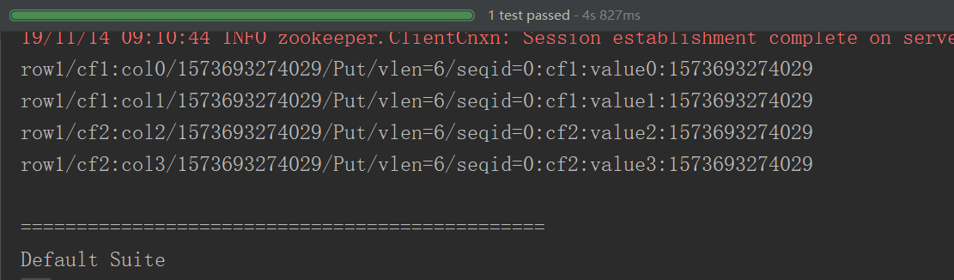

scan方法

private void ScanData()throws IOException{

getconncet();

Table table =connection.getTable(TableName.valueOf("NEWTABLE"));

Scan scan=new Scan();

ResultScanner results=table.getScanner(scan);

for (Result result:results){

for (Cell cell:result.rawCells()){

System.out.println(new String(CellUtil.getCellKeyAsString(cell))+":"+new String(CellUtil.cloneFamily(cell))+":"+new String(CellUtil.cloneValue(cell))+":"+cell.getTimestamp());

}

}

}

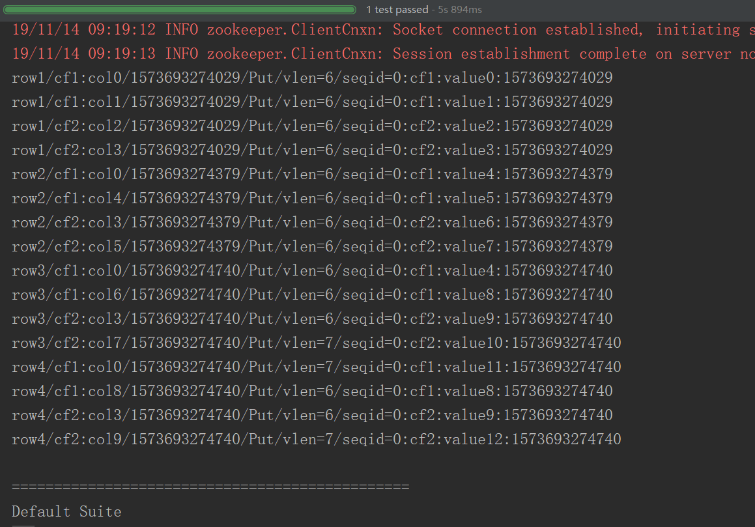

## 删除行和列

删除列族和列

private void removecol()throws IOException{

getconncet();

Admin admin=connection.getAdmin();

HTableDescriptor descriptor=admin.getTableDescriptor(TableName.valueOf("NEWTABLE"));

TableName tableName =TableName.valueOf("NEWTABLE");

descriptor.removeFamily(Bytes.toBytes("col0"));

admin.disableTable(tableName);

admin.deleteColumn(tableName, Bytes.toBytes("cf2"));

admin.enableTable(tableName);

admin.close();

}

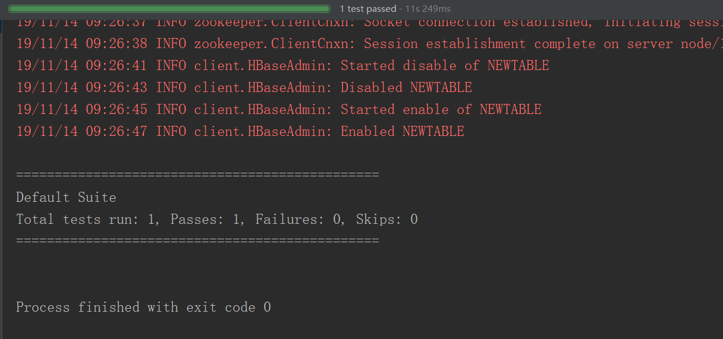

删除行和键值对

public void deleteRow()throws IOException{

getconncet();

HTable table=null;

try {

table=(HTable)connection.getTable(TableName.valueOf("NEWTABLE"));

Delete delete1=new Delete(Bytes.toBytes("row1"));

Delete delete2=new Delete(Bytes.toBytes("row2"));

Delete delete3=new Delete(Bytes.toBytes("row3"));

delete2.addFamily(Bytes.toBytes("cf1"));

delete3.addColumn(Bytes.toBytes("cf1"),Bytes.toBytes("col6"));

table.delete(delete1);

table.delete(delete2);

table.delete(delete3);

table.close();

}catch (Exception e){

}

}

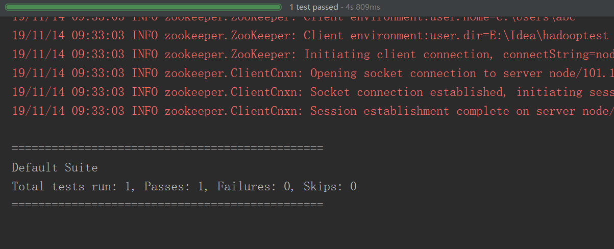

## 过滤器

public void filter()throws IOException{

getconncet();

TableName tableName =TableName.valueOf("NEWTABLE");

Table table=connection.getTable(tableName);

Scan scan=new Scan();

FilterList filterList=new FilterList(FilterList.Operator.MUST_PASS_ALL);

filterList.addFilter(new RowFilter(CompareFilter.CompareOp.LESS,new BinaryComparator(Bytes.toBytes("row3"))));

filterList.addFilter(new KeyOnlyFilter());

scan.setFilter(filterList);

ResultScanner results=table.getScanner(scan);

for (Result result:results){

for (Cell cell:result.rawCells()){

System.out.println(new String(CellUtil.getCellKeyAsString(cell))+":"+new String(CellUtil.cloneFamily(cell))+":"+new String(CellUtil.cloneValue(cell))+":"+cell.getTimestamp());

}

}

}

## 解决Java API不能远程访问HBase的问题

查看发现HBase绑定的是本地IP：127.0.0.1，这当然访问不了

netstat -anp|grep 16000



配置Linux的hostname

vim /etc/sysconfig/network

NETWORKING=yes

HOSTNAME=master

这里配置的hostname要Linux重启才生效，为了不重启就生效，我们可以执行：hostname master命令，暂时设置hostname

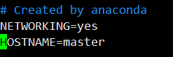

配置Linux的hosts，映射ip的hostname的关系

vi /etc/hosts

172.19.71.150 master

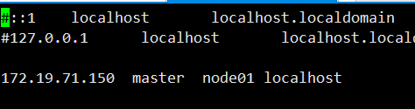

netstat -anp|grep 16000

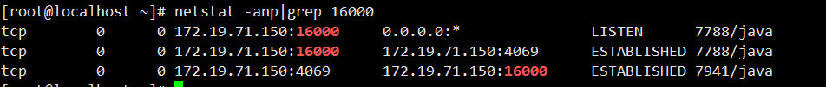

配置访问windows的hosts

路径为：C:\Windows\System32\drivers\etc\hosts

172.19.71.150 master

配置完这三项Java API就可以远程访问HBase了，切记最后配置windows的hosts也是必须的

# Python 访问Hbase

## CentOS安装Thrift

### 安装依赖

yum -y install automake libtool flex bison pkgconfig gcc-c++ boost-devel libevent-devel zlib-devel python-devel ruby-devel openssl-devel

### 安装boost包

cd /export/softwares/

wget <http://sourceforge.net/projects/boost/files/boost/1.53.0/boost_1_53_0.tar.gz>

tar xvf boost_1_53_0.tar.gz

cd boost_1_53_0

./bootstrap.sh

./b2 install

### 安装thrift

升级bison:

wget http://ftp.gnu.org/gnu/bison/bison-2.5.1.tar.gz

tar xvf bison-2.5.1.tar.gz

cd bison-2.5.1

./configure

make

make install

wget <http://mirrors.hust.edu.cn/apache/thrift/0.9.3/thrift-0.9.3.tar.gz>

tar xzvf thrift-0.9.3.tar.gz

cd thrift-0.9.3

./configure

make

make install

### 验证是否安装成功

thrift –version

## 打开HBase的Thrift服务

hbase-daemon.sh start thrift

hbase-daemon.sh start thrift2

## 客户端配置Python环境pip安装Thrift

conda create --name nosql python=3.7

conda activate nosql

conda install thrift

pip install hbase-thrift

## 修改代码文件

将Python2风格代码改为Python3

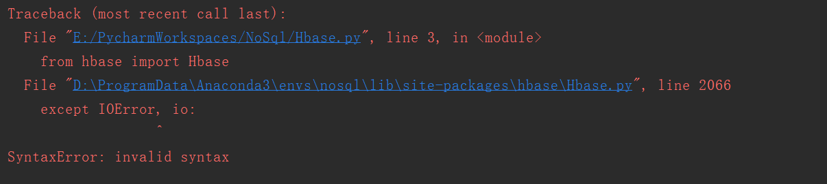

改为

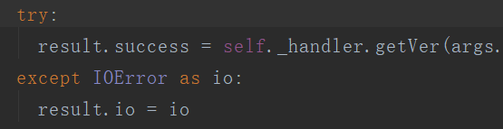

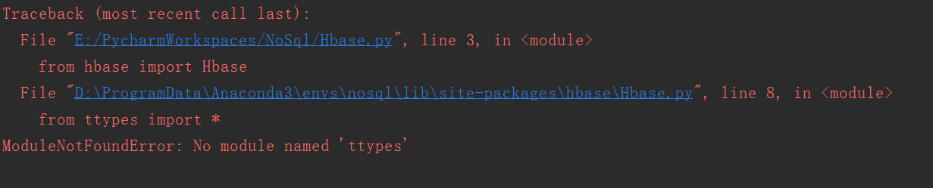

改为

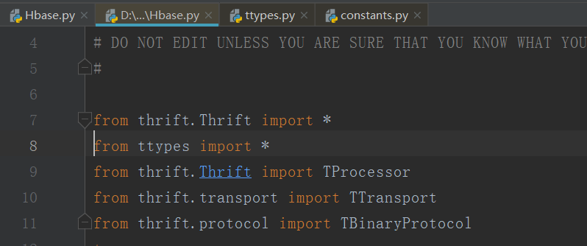 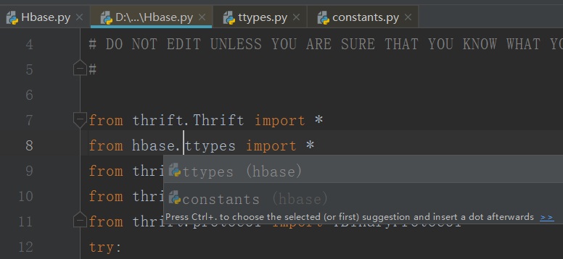

替换处理

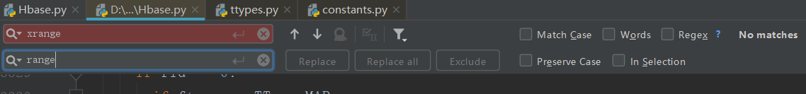







## 引用的类库

from thrift.transport import TSocket

from thrift.protocol import TBinaryProtocol

from hbase.Hbase import *

from hbase.ttypes import *

## 建立连接

transport = TSocket.TSocket("192.168.52.100",9090)

protocol = TBinaryProtocol.TBinaryProtocol(transport)

client=Client(protocol)

try:

transport.open()

except Exception as e:

print(e)

exit()

# 关闭连接

transport.close()

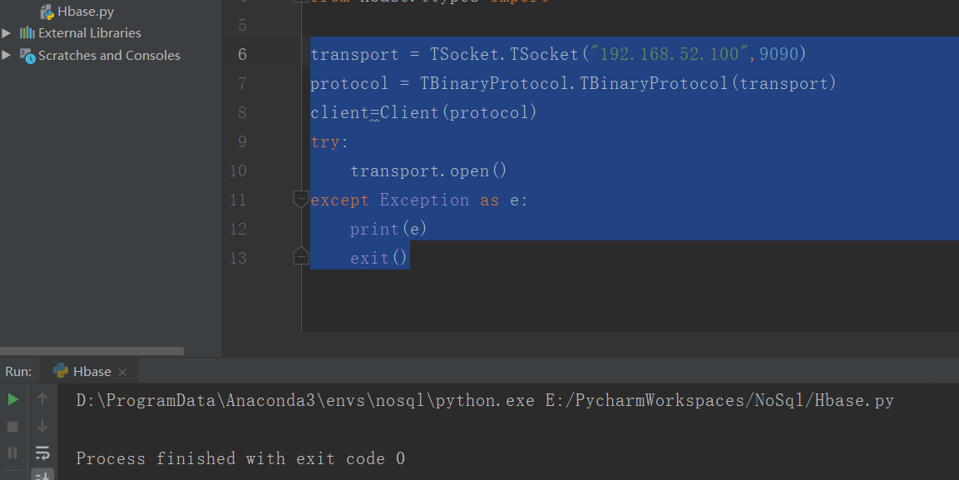

## 列举所有表名

TableNames=client.getTableNames()

print(TableNames)

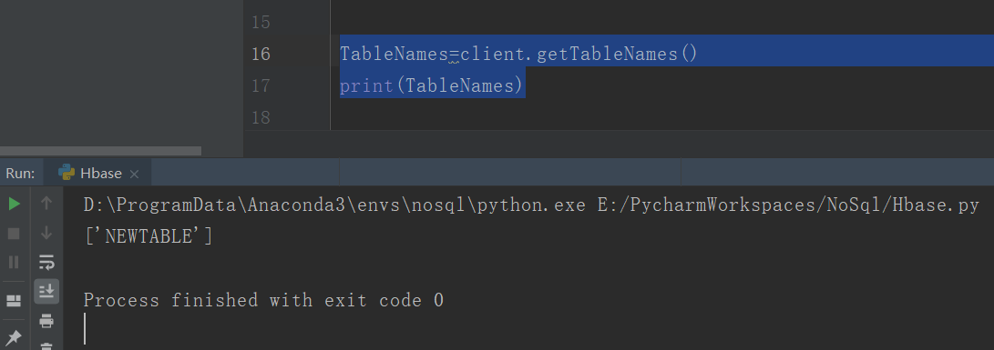

## 表的建立

content1=ColumnDescriptor(name='cf1',maxVersions=1)

content2=ColumnDescriptor(name='cf2',)

client.createTable('testtable',[content1,content2])

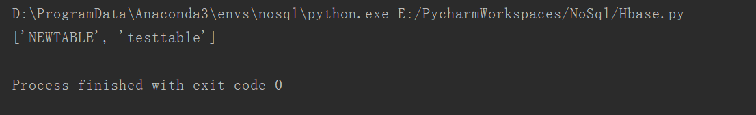

## 表的禁用删除

try:

client.disableTable('testtable')

client.deleteTable('testtable')

except:

pass

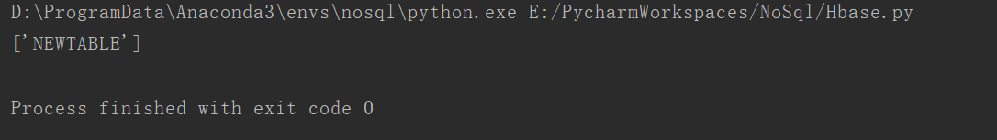

## 查看表结构

ColumnDescriptors=client.getColumnDescriptors('testtable')

print(ColumnDescriptors)



## 插入数据

mutations=[Mutation(column='cf1:a',value='1'),Mutation(column='cf1:c',value='20')]

client.mutateRow('testtable','row-key1',mutations)

## 检索数据

result=client.getRow('testtable','row-key1')

print(result)



for r in result:

print('rowkey:',r.row)

for c in r.columns.keys():

print("column qualifier:",c)

print('value:',r.columns[c].value)

print('timestamp:', r.columns[c].timestamp)

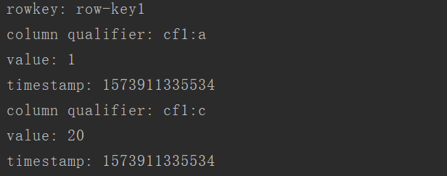

## 删除数据

client.deleteAllRow('testtable',row='row-key1')

client.deleteAllRowTs('testtable','row-key1',1573912214382)

## 安装Cassandra

cd /export/softwares/

wget <http://mirrors.tuna.tsinghua.edu.cn/apache/cassandra/3.0.19/apache-cassandra-3.0.19-bin.tar.gz>

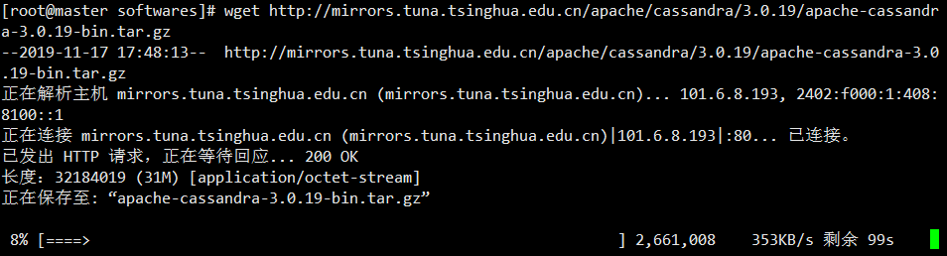

tar zxvf apache-cassandra-3.0.19-bin.tar.gz -C ../servers

vi /etc/profile

export CASSANDRA_HOME=/export/servers/apache-cassandra-3.0.19

export PATH=:$CASSANDRA_HOME/bin:$PATH

source /etc/profile

## 修改配置文件 cassandra.yaml

#进入$CASSANDRA_HOME/conf配置文件所在的目录

cd $CASSANDRA_HOME/conf

### a.修改cassandra集群的名字(默认是 Test Cluster)

# The name of the cluster. This is mainly used to prevent machines in

# one logical cluster from joining another.

cluster_name: 'Test Cluster'

### b.设置集群种子节点IP，如果多个用逗号分隔

# seeds is actually a comma-delimited list of addresses.

# Ex: "<ip1>,<ip2>,<ip3>"

- seeds: "192.168.52.100,192.168.52.110,192.168.52.120"

### c.设置监听地址(本机的IP)，是为了其他节点能与节点进行通信(默认是 localhost)，每台机器填自己机器的IP

# Setting listen_address to 0.0.0.0 is always wrong.

listen_address: 192.168.52.100

### d.开启 thrift rpc 服务(默认是 false)

# Whether to start the thrift rpc server.

start_rpc: true

### e.设置rpc的地址(默认是 localhost)

# For security reasons, you should not expose this port to the internet. Firewall it if needed.

rpc_address: 192.168.52.100

### f.设置数据文件所在路径(默认是 $CASSANDRA_HOME/data/data)

# If not set, the default directory is $CASSANDRA_HOME/data/data.

data_file_directories:

- /data1/cassandradata/data

- /data2/cassandradata/data

- /data3/cassandradata/data

- /data4/cassandradata/data

- /data5/cassandradata/data

### g.设置commitlog文件所在路径(默认是 $CASSANDRA_HOME/data/commitlog)

# If not set, the default directory is $CASSANDRA_HOME/data/commitlog.

commitlog_directory: /data6/cassandradata/commitlog

问：为什么要设置 data_file_directories 和 commitlog_directory？

答：因为这两个文件很大，分散集群中磁盘I/O压力，前者是cassandra实际数据存放的目录，后者是数据写入commitlog的文件目录

## 分发安装包

scp -r apache-cassandra-3.0.19/ node02:$PWD

scp -r apache-cassandra-3.0.19/ node03:$PWD

## 修改 $CASSANDRA_HOME/conf/cassandra.yaml 中的 listen_address 和 rpc_address 将其设置成自己的IP

## 启动cassandra

cassandra -r

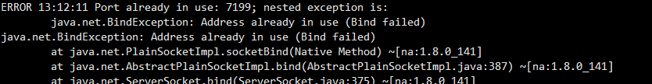

netstat -tunlp |grep 7199

cassandra -p cassandra.pid

pkill -F cassandra.pid

nodetool status

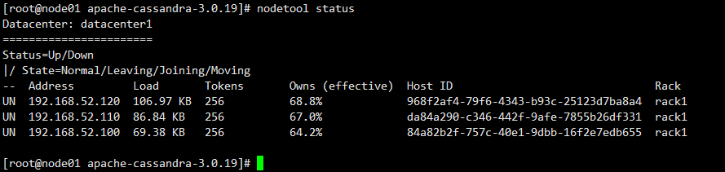

## CentOS 6.9下将python2.6.6升级为Python2.7.13

查看当前系统中的 Python 版本

python --version

返回 Python 2.6.6 为正常。

检查 CentOS 版本

cat /etc/redhat-release

返回 CentOS release 6.9 (Final) 为正常。

安装所有的开发工具包

yum groupinstall -y "Development tools"

安装其它的必需包

yum install -y zlib-devel bzip2-devel openssl-devel ncurses-devel sqlite-devel

下载、编译和安装 Python 2.7.13

wget https://www.python.org/ftp/python/2.7.13/Python-2.7.13.tgz

tar zxf Python-2.7.13.tgz

cd Python-2.7.13

./configure

make && make install

默认 Python 2.7.13 会安装在 /usr/local/bin 目录下。

ll -tr /usr/local/bin/python*

/usr/local/bin/python2.7

/usr/local/bin/python2.7-config

/usr/local/bin/python -> python2

/usr/local/bin/python2 -> python2.7

/usr/local/bin/python2-config -> python2.7-config

/usr/local/bin/python-config -> python2-config

而系统自带的 Python 是在 /usr/bin 目录下。

ll -tr /usr/bin/python*

/usr/bin/python2.6-config

/usr/bin/python2.6

/usr/bin/python

/usr/bin/python2 -> python

/usr/bin/python-config -> python2.6-config

更新系统默认 Python 版本

先把系统默认的旧版 Python 重命名。

mv /usr/bin/python /usr/bin/python.old

再删除系统默认的 python-config 软链接。

rm -f /usr/bin/python-config

最后创建新版本的 Python 软链接。

ln -s /usr/local/bin/python /usr/bin/python

ln -s /usr/local/bin/python-config /usr/bin/python-config

ln -s /usr/local/include/python2.7/ /usr/include/python2.7

以上步骤做完以后，目录 /usr/bin 下的 Python 应该是

ll -tr /usr/bin/python*

/usr/bin/python2.6-config

/usr/bin/python2.6

/usr/bin/python.old

/usr/bin/python2 -> python

/usr/bin/python -> /usr/local/bin/python

/usr/bin/python-config -> /usr/local/bin/python-config

查看新的 Python 版本

python --version

返回 Python 2.7.13 为正常。

以下步骤还是有必要的

为新版 Python 安装 setuptools

wget https://bootstrap.pypa.io/ez_setup.py -O - | python

setuptools 正确安装完成后，easy_install 命令就会被安装在 /usr/local/bin 目录下了。

wget https://pypi.python.org/packages/source/d/distribute/distribute-0.6.10.tar.gz

tar xf distribute-0.6.10.tar.gz

cd distribute-0.6.10

python2.7 setup.py install

wget http://curl.haxx.se/ca/cacert.pem

mv cacert.pem ca-bundle.crt

cp ca-bundle.crt /etc/pki/tls/certs/

为新版 Python 安装 pip

wget https://bootstrap.pypa.io/get-pip.py

python get-pip.py

至此，新版 Python 即算安装完毕了。

注意：这可能会导致以前安装过的 Python 程序运行不了或者无法重启之类的（比如著名的 Shadowsocks Python 版）。原因是旧版的 pkg_resources 位于 /usr/lib/python2.6/site-packages 下。而新版的则是在 /usr/local/lib/python2.7/site-packages 下。

所以，也许你需要重新安装一下程序。

再次注意：升级 Python 可能会导致 yum 命令不可用。解决方法如下：

编辑 /usr/bin/yum 文件，将开头第一行的

#!/usr/bin/python

改为

#!/usr/bin/python2.6

但是，这种改法，万一哪天你 yum update 了一下，yum 被升级了后，又变回老样子了。

记住旧版本 Python 2.6.6 的重要路径如下所示，在运行 yum 命令的时候，会提示你哪个 module 不存在，不存在的我们就去旧版本的路径下找，一定能找到的。找到后，复制到新版本 Python 的路径 /usr/local/lib/python2.7/site-packages/ 下即可。

/usr/lib/python2.6/site-packages/

/usr/lib64/python2.6/site-packages/

我的复制过程是这样的：

cp -r /usr/lib/python2.6/site-packages/yum /usr/local/lib/python2.7/site-packages/

cp -r /usr/lib/python2.6/site-packages/rpmUtils /usr/local/lib/python2.7/site-packages/

cp -r /usr/lib/python2.6/site-packages/iniparse /usr/local/lib/python2.7/site-packages/

cp -r /usr/lib/python2.6/site-packages/urlgrabber /usr/local/lib/python2.7/site-packages/

cp -r /usr/lib64/python2.6/site-packages/rpm /usr/local/lib/python2.7/site-packages/

cp -r /usr/lib64/python2.6/site-packages/curl /usr/local/lib/python2.7/site-packages/

cp -p /usr/lib64/python2.6/site-packages/pycurl.so /usr/local/lib/python2.7/site-packages/

cp -p /usr/lib64/python2.6/site-packages/_sqlitecache.so /usr/local/lib/python2.7/site-packages/

cp -p /usr/lib64/python2.6/site-packages/sqlitecachec.py /usr/local/lib/python2.7/site-packages/

cp -p /usr/lib64/python2.6/site-packages/sqlitecachec.pyc /usr/local/lib/python2.7/site-packages/

cp -p /usr/lib64/python2.6/site-packages/sqlitecachec.pyo /usr/local/lib/python2.7/site-packages/

## cqlsh基本用法

进入shell

cqlsh

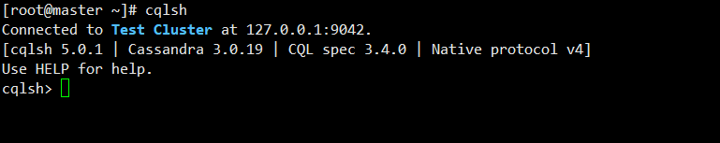

查看版本信息

show version



描述集群信息

describe cluster

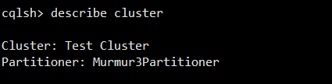

查看空间列表

desc keyspaces

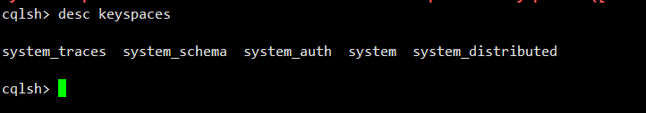

## 键空间管理

### 创建键空间

简单复制策略(SimpleStrategy)

create keyspace ks1 with replication={'class':'SimpleStrategy','replication_factor':'1'};

网络拓扑复制策略(NetworkTopologyStrategy)

create keyspace ks1 with replication={'class':'NetworkTopologyStrategy','dc1':3,'dc2':2 } AND DURABLE_WRITES=false;

### 删除键空间

drop keyspace ks1

### 查看键空间列表

describe keyspaces

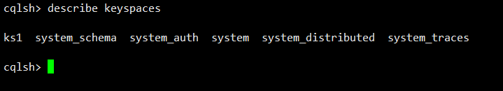

### 修改键空间属性

alter keyspace ks1 with replication ={'class':'SimpleStrategy','replication_factor':'2'};

### 系统键空间

select * from system_schema.keyspaces;

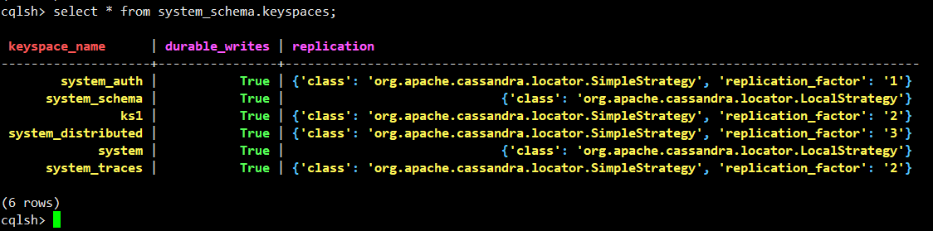

select * from system_schema.tables where keyspace_name='ks1';



select * from system_schema.columns where keyspace_name='ks1' AND table_name='address';



select * from system_schema.types;

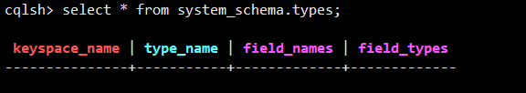

## 数据表管理

### 建立数据表

create table address(name text PRIMARY KEY,phone list<text>);



describe ks1;

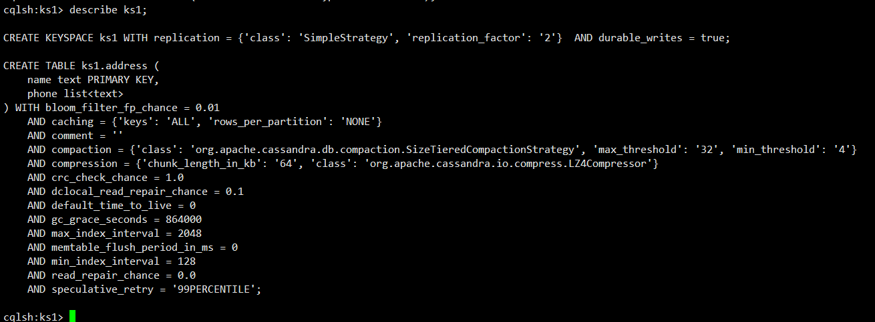

desc tables;

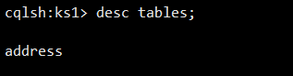

### 设置复合型主键

create table address2(name text,phone list<text> , primary key(name));

### 修改表结构

alter table address add age int;

alter table address with bloom_filter_fp_chance=0.01;

### 删除数据并重建表

truncate address;

## 用户自定义类型

create type scores(subject text,score int);

drop type scores;

## CQL数据查询

create table ks1.testtable1(

col1 text,

col2 int,

col3 tuple<text,text>,

PRIMARY KEY (col1,col2)

);

select * from ks1.testtable1;

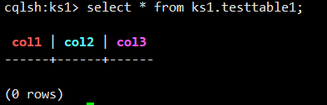

### 条件查询

create table test(

key int,

col1 int,

col2 int,

col3 int,

col4 int,

primary key((key),col1,col2,col3,col4)

);

insert into ks1.test(key,col1,col2,col3,col4) values(100,1,1,1,1);

insert into ks1.test(key,col1,col2,col3,col4) values(100,1,1,1,2);

insert into ks1.test(key,col1,col2,col3,col4) values(100,1,1,1,3);

insert into ks1.test(key,col1,col2,col3,col4) values(100,1,2,2,1);

insert into ks1.test(key,col1,col2,col3,col4) values(100,1,2,2,2);

insert into ks1.test(key,col1,col2,col3,col4) values(100,1,2,2,3);

insert into ks1.test(key,col1,col2,col3,col4) values(100,1,2,2,1);

insert into ks1.test(key,col1,col2,col3,col4) values(100,2,1,2,2);

insert into ks1.test(key,col1,col2,col3,col4) values(100,2,1,2,3);

insert into ks1.test(key,col1,col2,col3,col4) values(100,2,1,1,1);

insert into ks1.test(key,col1,col2,col3,col4) values(100,2,1,1,2);

insert into ks1.test(key,col1,col2,col3,col4) values(100,2,1,1,3);

insert into ks1.test(key,col1,col2,col3,col4) values(100,2,2,2,1);

insert into ks1.test(key,col1,col2,col3,col4) values(100,2,2,2,2);

insert into ks1.test(key,col1,col2,col3,col4) values(100,1,2,2,3);

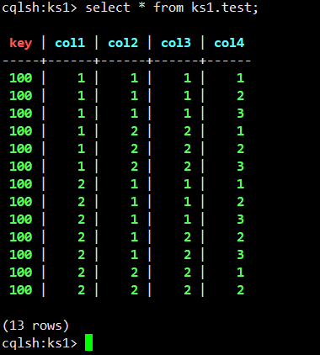

select * from test where key =100 and col1 in (1,2) and col2=1 and col3=1 and col4<=2;

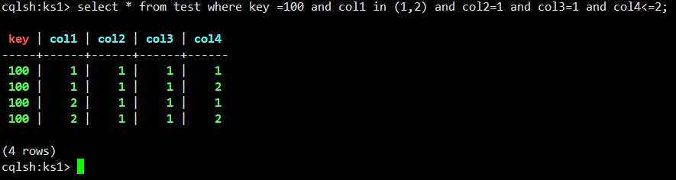

### 切片查询

select * from test where key=100 and col1=1 and col2=1 and (col3,col4)>=(1,2) and (col3,col4)<(2,3);

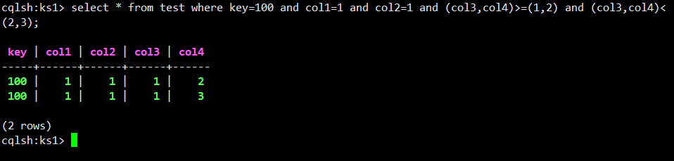

## 索引机制

建立索引

create index indexofaddress on address(age) ;

删除索引

drop index indexofaddress;

## 使用标量函数

select writetime(col3) from ks1.testtable1;

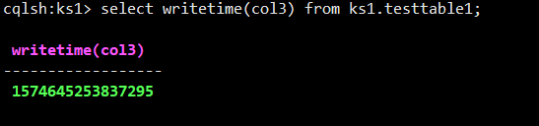

select token(col3) from ks1.testtable1;

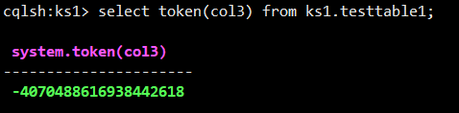

# 数据更新

## 插入更新删除

### 数据插入

insert into ks1.testtable1(col1,col2,col3) values('some text',1,('the ket','the value'));

insert into ks1.testtable1(col1,col2,col3) values('other text',1,('another ket','another value'));

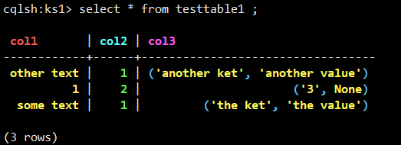

insert into ks1.testtable1(col1,col2,col3) values('some text',1,('a','b'));

insert into ks1.testtable1(col1,col2,col3) values('sther text',1,('c','d'));

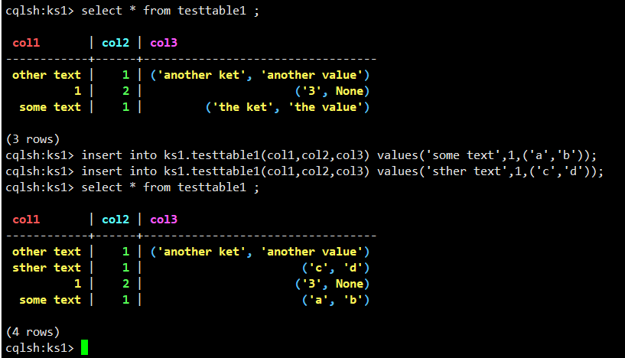

### 数据更新

update ks1.testtable1 set col3 = ('anykey','new value') where col1='some text' and col2=1;

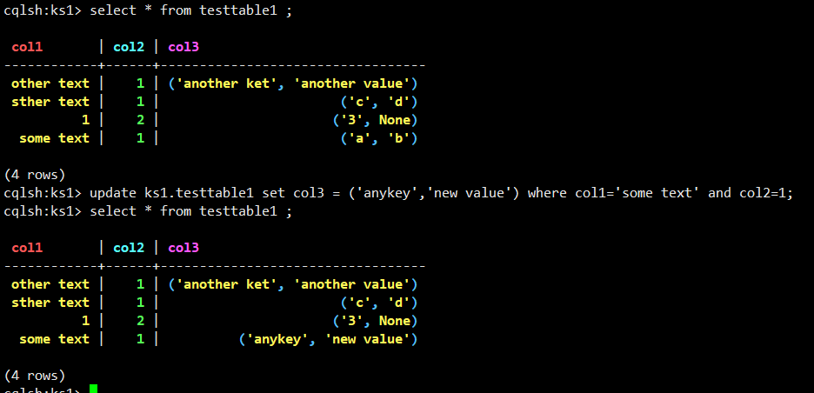

### 数据删除

DELETE col3 FROM ks1.testtable1 WHERE col1='some test'and col2=1;

DELETE from ks1.testtable1 where col1='other text' and col2=10;

### json格式插入数据

insert into ks1.testtable1 JSON '{"col1":"json test","col2":1000}';

## 读写一致性

### 查看一致性设置

CONSISTENCY ;

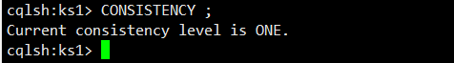

### if 轻量级事物

insert into ks1.testtable1(col1,col2,col3) values('some test',1,('another key','another value')) if not exists;

## 集合列操作

create table testtable2(

col1 int PRIMARY KEY,

col2 list<text>,

col3 map<text,text>,

col4 set<text>,

col5 frozen<tuple<text,text>>

);

INSERT INTO ks1.testtable2(col1,col2,col3,col4,col5) VALUES (1,['apple','apple','banana','cherry','banana'],{'1':'apple','1':'banana','3':'cherry','4':'cherry'},{'apple','banana','cherry','apple'}, ('apple','banana'));

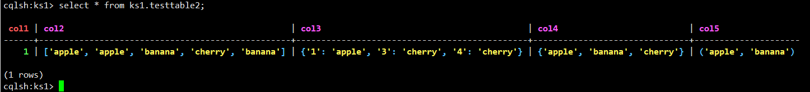

### list类型更新删除

update ks1.testtable2 set col2[2] = 'big apple' where col1 = 1 ;

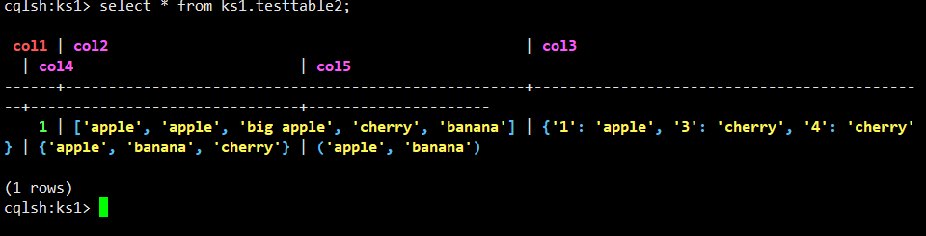

delete col2[2] from ks1.testtable2 WHERE col1 =1;

delete col2 FROM ks1.testtable2 where col1=1;

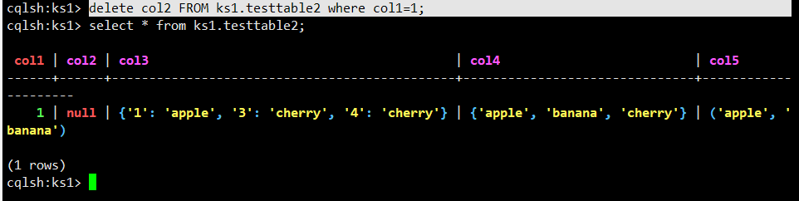

### set类型更新和删除

UPDATE ks1.testtable2 set col4=col4+{'big apple','small apple'} where col1=1;

DELETE col4 FROM ks1.testtable2 WHERE col1=1;

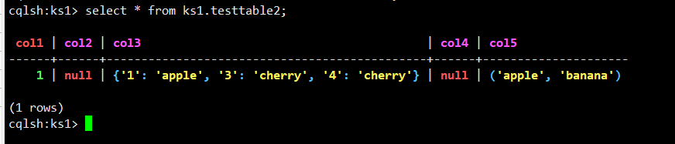

## nodetool工具

## 查看集群状态

nodetool version



nodetool ring

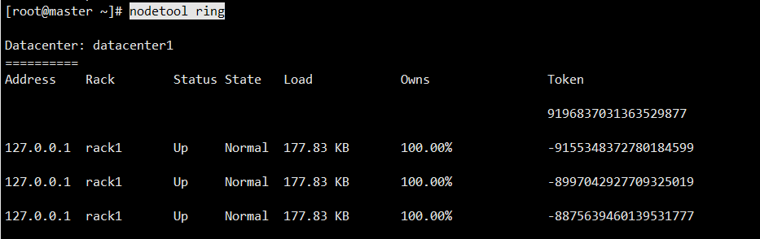

### 查看compation信息

nodetool compactionstats

# JAVA访问Cassandra

## 修改pom.xml

<!-- https://mvnrepository.com/artifact/com.datastax.cassandra/cassandra-driver-core -->

<dependency>

<groupId>com.datastax.cassandra</groupId>

<artifactId>cassandra-driver-core</artifactId>

<version>3.7.2</version>

</dependency>

package cassandra;

import com.datastax.driver.core.Cluster;

import com.datastax.driver.core.ColumnDefinitions.Definition;

import com.datastax.driver.core.ResultSet;

import com.datastax.driver.core.Row;

import com.datastax.driver.core.Session;

import org.testng.annotations.Test;

public class Cassandra {

public Cluster cluster;

public Session session;

public void connect(){

Cluster culster=Cluster.builder().withClusterName("Test Cluster").addContactPoint("192.168.52.129").build();

session=culster.connect();

}

/**

* 创建键空间

*/

public void createKeyspace()

{

/**单数据中心 复制策略 ：1**/

String cql = "CREATE KEYSPACE if not exists mydb WITH replication = {'class': 'SimpleStrategy', 'replication_factor': '1'}";

session.execute(cql);

}

/**

* 创建表

*/

public void createTable()

{

/** a,b为复合主键 a：分区键，b：集群键**/

String cql = "CREATE TABLE if not exists mydb.test (a text,b int,c text,d int,PRIMARY KEY (a, b))";

session.execute(cql);

}

/**

* 插入

*/

public void insert()

{

String cql = "INSERT INTO mydb.test (a , b , c , d ) VALUES ( 'a2',4,'c2',6);";

session.execute(cql);

}

/**

* 修改

*/

public void update()

{

// a,b是复合主键 所以条件都要带上，少一个都会报错，而且update不能修改主键的值，这应该和cassandra的存储方式有关

String cql = "UPDATE mydb.test SET d = 1234 WHERE a='aa' and b=2;";

// 也可以这样 cassandra插入的数据如果主键已经存在，其实就是更新操作

String cql2 = "INSERT INTO mydb.test (a,b,d) VALUES ( 'aa',2,1234);";

// cql 和 cql2 的执行效果其实是一样的

session.execute(cql);

}

/**

* 删除

*/

public void delete()

{

// 删除一条记录里的单个字段 只能删除非主键，且要带上主键条件

String cql = "DELETE d FROM mydb.test WHERE a='aa' AND b=2;";

// 删除一张表里的一条或多条记录 条件里必须带上分区键

String cql2 = "DELETE FROM mydb.test WHERE a='aa';";

session.execute(cql);

session.execute(cql2);

}

/**

* 查询

*/

public void query()

{

String cql = "SELECT * FROM mydb.test;";

String cql2 = "SELECT a,b,c,d FROM mydb.test;";

ResultSet resultSet = session.execute(cql);

System.out.print("这里是字段名：");

for (Definition definition : resultSet.getColumnDefinitions())

{

System.out.print(definition.getName() + " ");

}

System.out.println();

System.out.println(String.format("%s\t%s\t%s\t%s\t\n%s", "a", "b", "c", "d",

"--------------------------------------------------------------------------"));

for (Row row : resultSet)

{

System.out.println(String.format("%s\t%d\t%s\t%d\t", row.getString("a"), row.getInt("b"),

row.getString("c"), row.getInt("d")));

}

}

@Test

public void Test(){

connect();

createKeyspace();

createTable();

insert();

update();

delete();

query();

}

}

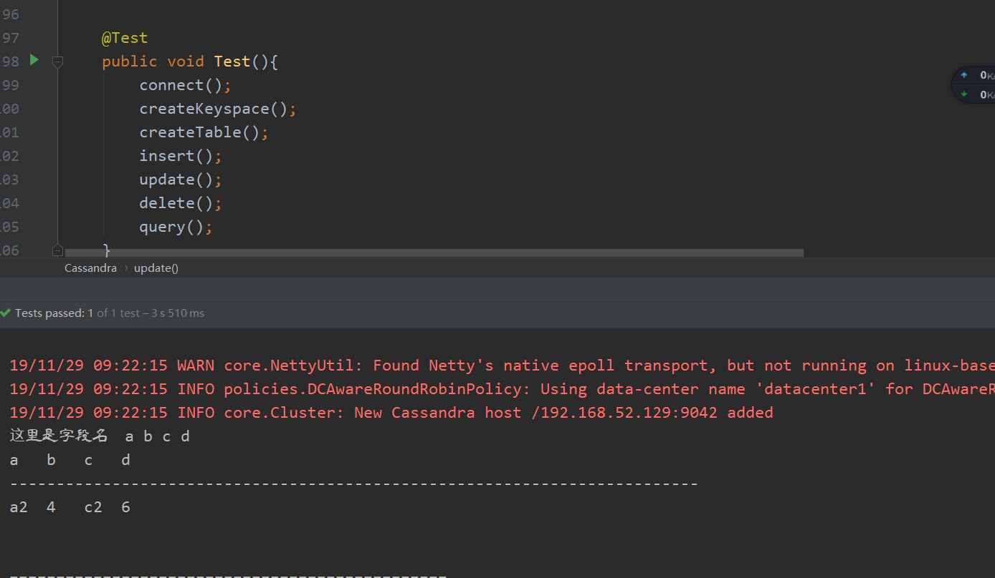

## Python访问Cassandra

pip install cassandra-driver

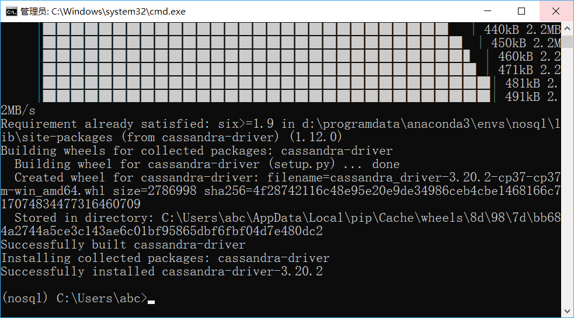

# encoding=UTF-8

from cassandra.cluster import Cluster

cluster = Cluster(['192.168.52.129'])

cluster.port=9042

session = cluster.connect()#创建连接

session_keyspace = cluster.connect("ks1") #直接连接keyspace

'''

对Cassandra进行操作

'''

#1. 创建键空间

#1.1 使用SimpleStrategy策略创建键空间

'''

简单复制策略是指在一个数据中心的情况下使用简单的策略.该策略中,第一个副本被放置在所选择的节点上,剩下的节点采用Dynamo论文中的副本策略,不考虑机架位置

'''

#'replication':n用于指示副本数量

#session.execute("create keyspace test with replication={'class':'SimpleStrategy','replication_factor':'1'};")

#1.2网络拓补复制策略,在该策略下,数据副本采用二级机架感知策略

#Durable_writes默认为true,表示数据再写入时,先持久化在预写日志中,便于故障恢复.再网络拓补复制策略下,该选项可设置为false,但有数据丢失的风险

#session.execute("create keyspace ks3 with replication={'class':'NetworkTopologyStrategy','dc1':3,'dc2':2} and durable_writes=false;")

#1.4 查看键空间列表

#在cqlsh里可使用 describe spaces;查询键空间列表,但execute不支持describe命令

print(cluster.metadata.keyspaces)

print("\n")

# 因为cassandra为键值对的存储方式,所以,可使用类似显示字典内容的方式输出键空间

for k,v in cluster.metadata.keyspaces.items():

print(k,v)

#1.5 修改键空间属性

session.execute("alter keyspace ks1 with replication={'class':'SimpleStrategy','replication_factor':2}")

#1.7 系统键空间

'''

system_schema表中存储当前所有的键空间和数据表的局部信息(schema信息)

'''

result_keySpace=session.execute("select * from system_schema.keyspaces;")

for i in result_keySpace:

print(i)

for j in i:

print(j)

'''

所有数据表的信息存储于系统表system_shema.tables中

'''

result_ks1_tables=session.execute("select * from system_schema.tables where keyspace_name = 'ks1';")

for i in result_ks1_tables:

print(i)

'''

所有数据表的列信息存储于system_schema.columns中

'''

result_ks1_columns=session.execute("select * from system_schema.columns where keyspace_name = 'ks1';")

for i in result_ks1_columns:

print(i)

'''

所有用户自定义数据类型都存储在system_schema.types中

'''

result_ks1_udf = session.execute("select * from system_schema.types")

for i in result_ks1_udf:

print(i)

'''

创建表,在此之前需要保证是先使用目标键空间

'''

session.execute("use ks1;")

#2.1建表操作

# session.execute("create table py(name text primary key,phone list<text>);")

print([i for i in session.execute("select table_name from system_schema.tables where keyspace_name='ks1';")])

# 几种特殊的数据类型：Map（键值对）、Set、list、Frozen（非具体类型，强调对被frozen限制的整体的操作，例如:frozen<tuple<text,text>>）

#2.2 删除表

session.execute("drop table address;")

#2.3 设置复合型主键

'''

可直接在单一主键后加primary key，也可单独设置。

默认情况下，复合型主键的第一个主键为分区键(列)，其他为分簇键(列)

分簇列可单独设定升序(ASC)与降序(DESC)

'''

session.execute("create table address(firstname text,lastname text,No int,phone list<text>,primary key((firstname,lastname),No)) with clustering order by(No DESC);")

#2.4 修改表结构

'''

alter 仅支持 add drop rename 操作

'''

session.execute("alter table address add age int;")

print([i for i in session.execute("select column_name,type from system_schema.columns where keyspace_name='ks1' and table_name='address';")])

session.execute("alter table address drop age;")

print([i for i in session.execute("select column_name,type from system_schema.columns where keyspace_name='ks1' and table_name='address';")])

#间接查询，注意：若未设置索引，查询需添加ALLOW FILTER子句作为条件(性能无法预测)

print([i for i in session.execute("select * from system_schema.tables where table_name='stu' allow filtering;")])

cluster.shutdown()#关闭连接

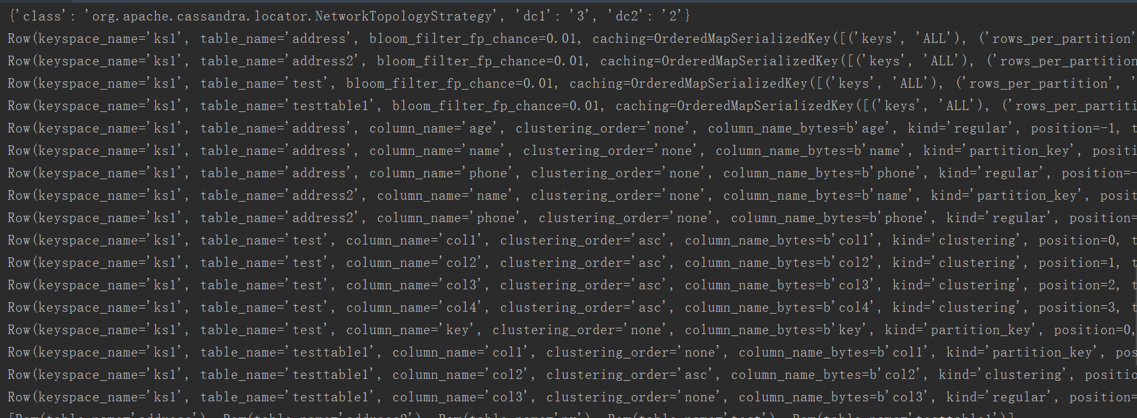

# MongoDB安装

## yum安装

创建yum源文件：

cd /etc/yum.repos.d

vim mongodb-org-4.0.repo

添加以下内容：

[mngodb-org]

name=MongoDB Repository

baseurl=http://mirrors.aliyun.com/mongodb/yum/redhat/7Server/mongodb-org/4.0/x86_64/

gpgcheck=0

enabled=1

安装MongoDB

安装命令：

yum -y install mongodb-org

安装完成后,查看mongo安装位置

whereis mongod



systemctl start mongod.service

## 解压安装

MongoDB官网 <https://www.mongodb.com>

cd /export/softwares/

wget https://fastdl.mongodb.org/linux/mongodb-linux-x86_64-4.0.2.tgz

tar zxvf mongodb-linux-x86_64-4.0.2.tgz -C ../servers/

vi /etc/profile

export MONGODB_HOME=/export/servers/mongodb-linux-x86_64-4.0.2

export PATH=:$MONGODB_HOME/bin:$PATH

cd /export/servers/mongodb-linux-x86_64-4.0.2

mkdir -p /export/servers/mongodb-linux-x86_64-4.0.2/db

开启mongodb

mongod --dbpath /export/servers/mongodb-linux-x86_64-4.0.2/db

关闭mongodb

mongod -shutdown

进入shell

mongo --host 127.0.0.1:27017

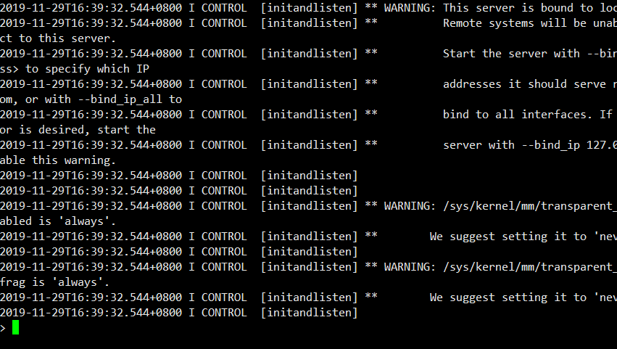

## 配置文件

vi /etc/mongod.conf

bindIp: 0.0.0.0

# shell

mongo

# 数据库和集合操作

## 数据库操作

查看当前连接服务器

db.getMongo()



查看数据库列表

show dbs

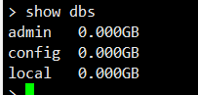

切换数据库

use test



查看数据库中所有集合

show collections

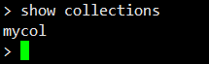

json显示集合名称

db.getCollectionNames()



集合详细信息

db.getCollectionInfos()

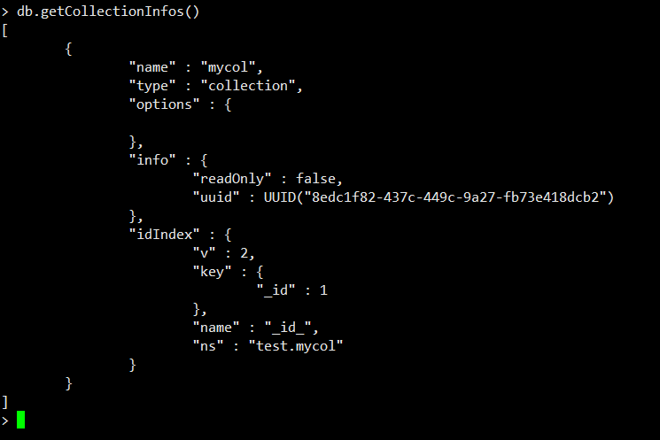

显示当前数据库名

db

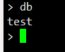

删除数据库

db.dropDatabase()

## 集合操作

新建集合

db.createCollection("mycol")



删除集合

db.myCol.drop()

## 基本增删改查操作

文档插入

db.mycol.insert({

item1:'111111',

item2:'22222222',

3:'33333333333333333333333',

4:44444444444444,

5:[1,2,'3']

})

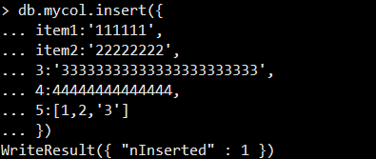

查看文档

db.mycol.find()

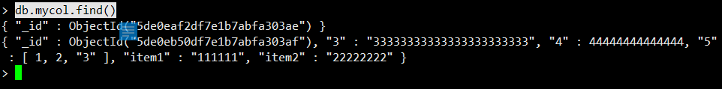

db.mycol.find().pretty()

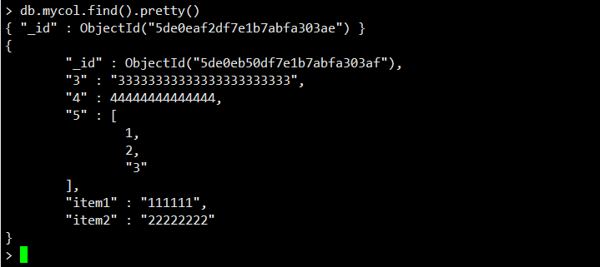

## 文档更新

db.mycol.update({'4':{$gt:0}},{$set:{'item2':'OK'}});

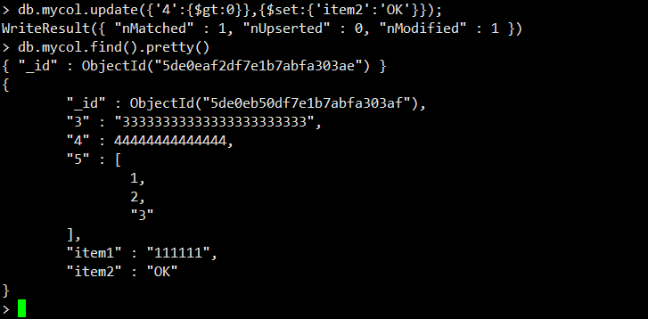

文档删除

db.mycol.remove({'4':{$gt:0}},true)

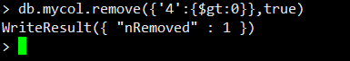

db.mycol.remove({})

## 聚合和管道

db.mycol.aggregate({$group:{_id:"item1",num:{$sum:1}}})

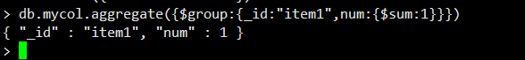

db.mycol.aggregate({$project:{item1:1, item2:1, item3:1}})



db.mycol.aggregate({$match:{"item3":{$gt:1,$gt:15}}})

db.mycol.aggregate({$sort:{"item2":1}})



db.mycol.aggregate({$unwind:'$item4'})

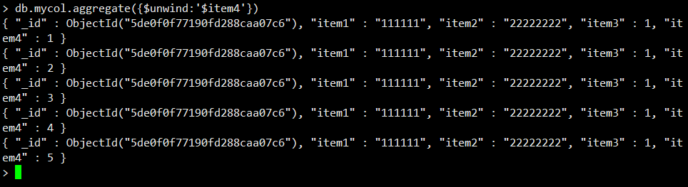

## 索引操作

db.mycol.createIndex({"item1":1})

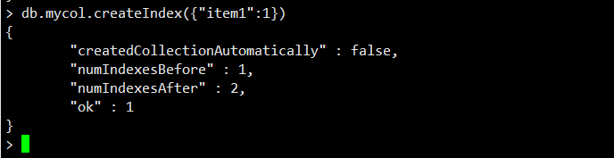

查看索引

db.mycol.getIndexes()

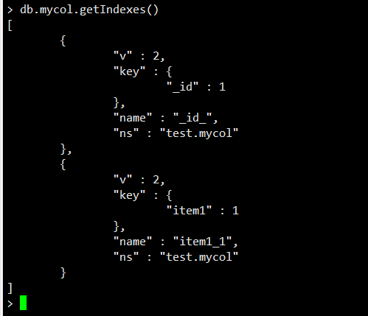

删除索引

db.mycol.dropIndex("myindex")



db.mycol.dropIndexes()

全文索引

db.mycol.createIndex({"item1":"text"})

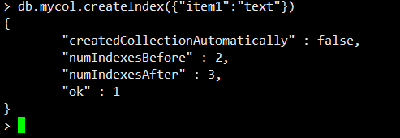

# python访问MongoDB

## 安装

pip install pymongo

## 导包

from pymongo import MongoClient

## 建立连接

client=MongoClient("192.168.52.129:27017")

## 切换数据库

db=client.get_database("testdb")

db=client.testdb

## 切换集合

col=db.testcol

## 定义JSON文档

item={

"name":"fruits",

"count_of":3,

"varieties":['banana',"cherry","orange"]

}

item1={

"name":"fruits",

"count_of":4,

"varieties":['banana',"cherry","orange"]

}

item2={

"name":"fruits",

"count_of":5,

"varieties":['banana',"cherry","orange"]

}

## 插入记录

col.insert_one(item)

col.insert_one(item1)

col.insert_one(item2)

## 查看数据

print(col.find_one())



## 更新数据

col.update_many({"name":"fruits"},{"$push":{"varieties":"lemen"}})

print(col.find_one())



## $push $each插入多个元素

col.update_many({"name":"fruits"},{"$push":{"varieties":{"$each":["1",'2','3']}}})

print(col.find_one())

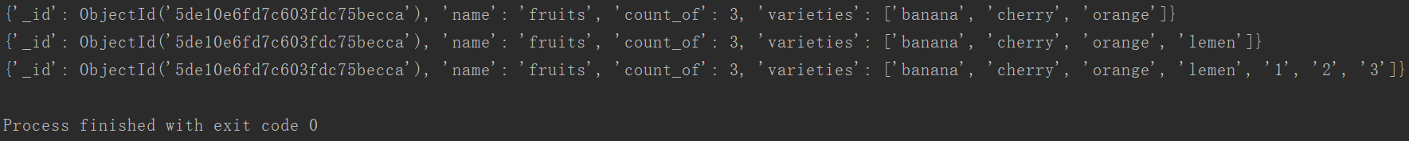

## 累加方式更新数字类型元素

col.update_many({"name":"fruits"},{"$inc":{"count_of":1}})

print(col.find_one())

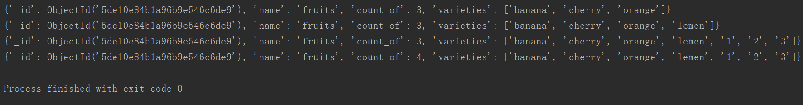

## $pop删除数据

col.update_many({"name":"fruits"},{"$pop":{"varieties":-1}})

print(col.find_one())

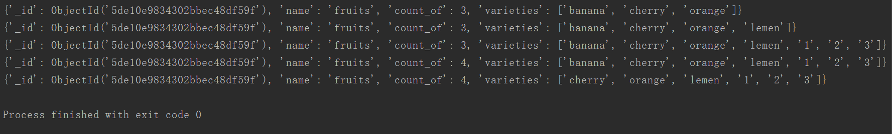

## 更新数据

col.update_many({"name":"fruits"},{"$set":{"count_of":10}})

print(col.find_one())

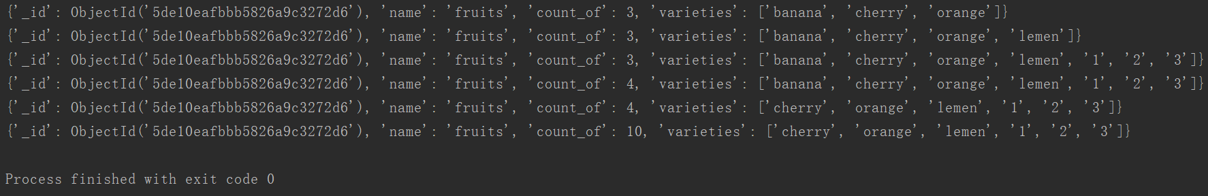

## 查看数据

print(col.find_one({"name":"fruits"}))

## 排序 限制 跳过

for r in col.find({"name":"fruits"}).sort("count_of").limit(3).skip(2):

print(r)

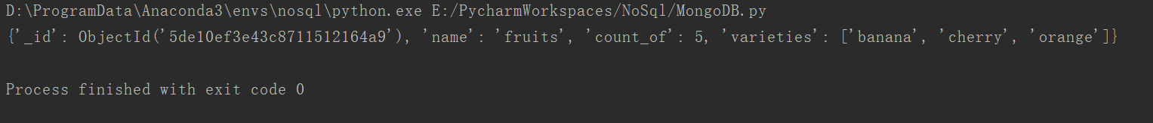

## 控制显示的列

for r in col.find({"name":"fruits"},projection={'count_of':False}):

print(r)

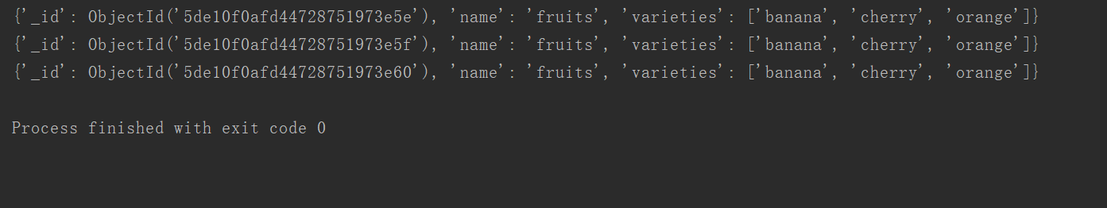

## 聚合查询

print(col.find({"name":"fruits"}).count())

print(col.count_documents({"name":"fruits"}))

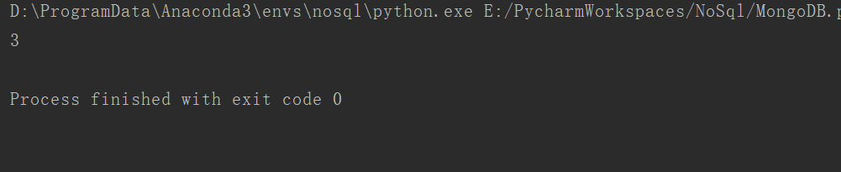

## 比较运算符

for r in col.find({"count_of":{"$lt":4}}):

print(r)

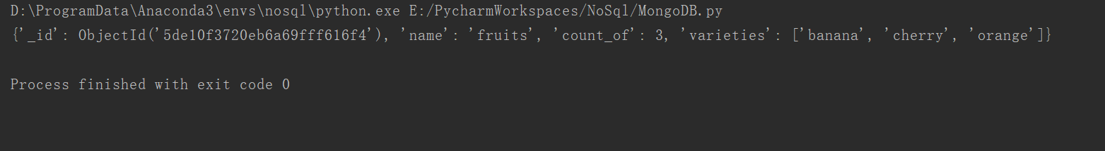

## 地理索引查询

from pymongo import GEO2D

db.places.create_index([("loc",GEO2D)])

#插入经纬度信息

result = db.places.insert_many([{"loc": [2, 5]},{"loc":[30, 5]},{"loc": [1, 2]},{"loc": [4, 4]}])

# $near 查询

for doc in db.places.find({"loc": {"$near": [3, 6]}}).limit(3):

print(doc)

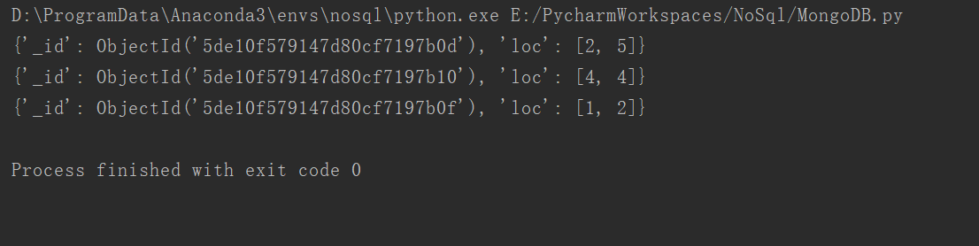

## Gridfs操作

import gridfs

fs=gridfs.GridFS(db)

fileid=fs.put(b"hello word",filename="testfile")

print(fs.exists({'filename':'testfile'}))

print(fs.list())

for doc in fs.find({"filename":"testfile"}):

print(doc._id)

print(doc.filename)

print(doc.read())

#删除

fs.delete(doc._id)

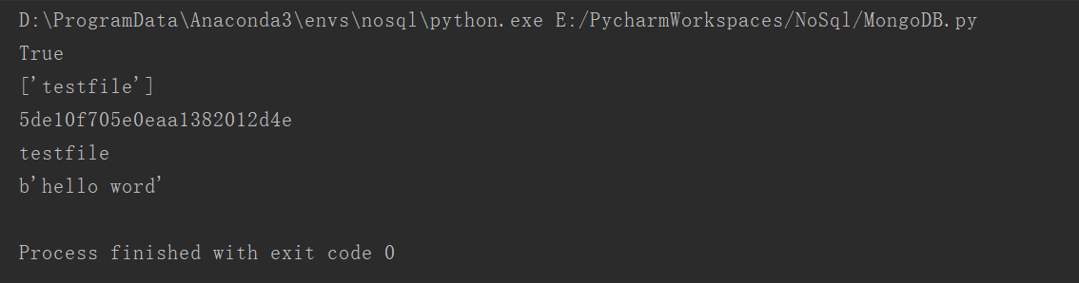

## 删除数据

col.delete_one({"name":"fruits"})

print(col.find_one())

## 删除集合

db.places.delete_many({})

db.drop_collection("testcol")

# Neo4j安装

## 下载Neo4j

1. 访问neo4j官网下载，官网地址：[https://neo4j.com/](https://links.jianshu.com/go?to=https%3A%2F%2Fneo4j.com%2F)

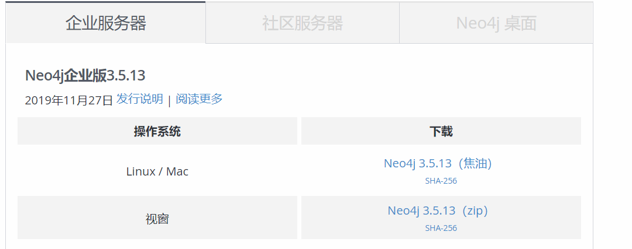

1. 访问微云数据主页：[http://we-yun.com/index.php/blog/releases-56.html](https://links.jianshu.com/go?to=http%3A%2F%2Fwe-yun.com%2Findex.php%2Fblog%2Freleases-56.html)，提供国内ftp下载地址：[ftp://neo4j.55555.io/neo4j/3.5.6/](https://links.jianshu.com/go?to=ftp%3A%2F%2Fneo4j.55555.io%2Fneo4j%2F3.5.6%2F)

## 安装

tar zxvf neo4j-community-3.5.6-unix.tar.gz -C ../servers/

cd /export/servers/neo4j-community-3.5.6/

vim conf/neo4j.conf

dbms.connectors.default_listen_address=0.0.0.0

dbms.connectors.default_advertised_address=0.0.0.0

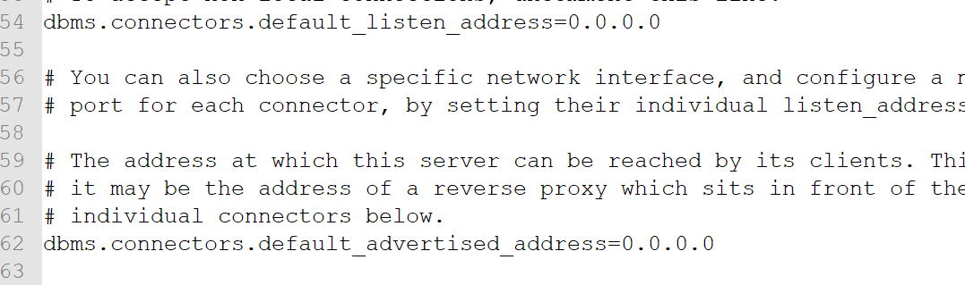

vi /etc/profile

export NEO4J_HOME=/export/servers/neo4j-community-3.5.6

export PATH=:$NEO4J_HOME/bin:$PATH

source /etc/profile

## 启动neo4j服务

neo4j start

## 访问web

<http://192.168.52.129:7474/browser/>

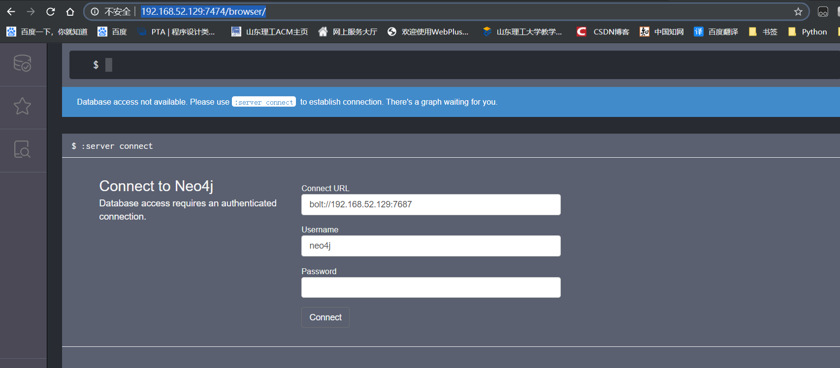

登录界面默认填充了用户名neo4j。

输入默认密码neo4j后，修改密码123456，进入neo4j

# Python访问Neo4j

安装驱动

pip install neo4j-driver

导包

from neo4j import GraphDatabase

建立连接

driver=GraphDatabase.driver("bolt://192.168.52.129",auth=("neo4j", "123456"))

session = driver.session()

传递Cypher语句

session.run("CREATE (a:Persion {name:'alice'})")  
result=session.run("MATCH (a:Persion) RETURN a.name")  
for i in result:  
 print(i['a.name'])  
  
result = session.run("MATCH (a:Persion) RETURN a")  
for i in result:  
 print(i['a'])

关闭连接

session.close()

